National Institute of Science, Technology and Innovation on
Advanced Complex Materials (Inomat)

Annual Activity Report


First year: 24/4/2009-20/5/2010
Contents

This report…2
The Institute…2
The first year…3
Highlights…4
Research…4
Innovation, cooperation with industrial and knowledge transfer…13
Education…14
Diffusion of knowledge…14
Materials…18
Project Personnel…20
Inomat fellowships granted to students and post-docs…29
Publications…30
Doctoral and Masters´s thesis approved…39
Patent applications…41
Presentations in conferences and symposia…42
Conclusion…50

May 2010

This report is a companion to the formal evaluation document form sent to MCT and Fapesp. It describes the first year of activities of Inomat, the National Institute of Science, Technology and Innovation on Advanced Complex Materials. Its contract was signed on April 30 2009 that is thus formally defined as its starting date. Since project groups were already moving ahead along the plans presented in the project application in early 2008, results reported here refer to the year of 2009 and the first four months of 2010.

The format used in this report follows the guidelines sent by CNPq and Fapesp, in various moments.

The Institute: organization and infra-structure
Organization
Inomat is a network structure with nodes located in the State universities of Campinas, São Paulo (SP) and Maringá (PR) as well as in the Federal universities of Bahia, Ceará and Rio de Janeiro. Each local group is installed in pre-existing facilities under local management and fitted within local organization structures.
Institute coordinator is Fernando Galembeck from Unicamp, the University of Campinas. Grant management is done following the “pessoa física” format for funds received both from CNPq and Fapesp.
Planning and follow up of the Inomat activities are done by a board (Comitê Gestor) formed by Adley Forti Rubira (Maringá), José Manuel Riveros Nigra (USP), Marco Antonio Chaer do Nascimento (UFRJ) and Oswaldo Luiz Alves (Unicamp, Vice-coordinator). Implementation of Board decisions is under the responsibility of the Coordinator and Vice-Coordinator. The Board met twice, on November 7 2009 and on April 24 2010.
Clerical activities and document handling are done by two technical assistants from the laboratory of Fernando Galembeck: one is a Unicamp employee and the other is hired by Funcamp, using funds from other projects, mainly with industry.
The head office is installed in the Institute of Chemistry (Bloco J) of Unicamp. The scientific-technological internal communication and information between the members is normally done by using the website http://www.inomat.iqm.unicamp.br and the omat @iqm.unicamp.br e-mail address.
A full list of Inomat scientific personnel is given in a separate section ahead.

Infra-structure
The participating groups have good working facilities that were described in the initial project submitted in 2009. These are now being improved with acquisitions of equipment and some lab floor expansion as well as the improvement of laboratory installations.
Main instrument acquisitions done so far are the following:

Acquisitions made by FAPESP

1 – Electron transmission microscope with electron energy-loss spectrometer and tomograph (Unicamp). Arrived, installed, under testing.
2 – Ultra-sensitive camera and image acquisition system (Unicamp). Arrived.
3 – High-performance Nd laser (USP). Arrived.
4 – Parametric oscillator coupled to parametric optical amplifier (USP) – to be desembarked in the 18th week 2010.
5 – Laser Ar/Kr (USP). Arrived.
6 – Cryostat (USP). To be delivered.
7 – Bomba turbomolecular (USP). To be delivered.
8 – Bomba de diafragma duplo estágio (USP). To be delivered.

Acquisitions made by CNPq

1 – Confocal Raman microscope– (UEM) – In progress.
2 – Thermal analysis system – (UFRJ). In progress.
3 – SGI Altix ICE 8200 LX – (UFRJ). In progress.
4 – AFM micoscope – (UFRJ). In progress.
5 – Liquid chromatography system with data analysis software – (UFRJ)
6 – Quantum efficiency system – (Unicamp)
7 – Photon counter module for light scattering equipment – (Unicamp)

In some cases, new equipment is an upgrade of existing facilities. This is the case of the transmission electron microscope acquired with funds from FAPESP within this project. It is replacing a 20 years old instrument but bringing significant improvements in spacial and spectral resolution. Moreover, the new instrument is equipped with attachments for making electron tomography.

The first year
The project was submitted in September 18 2008, initially rejected in the first INCT program assessment in October 2008 and finally approved in April 16 2009 (date of the Grant Document). During the first year of operation the various research, knowledge transfer and diffusion activities derived from previous work of the Inomat researchers and proposed in the project submitted to the INCT Program were initiated and/or expanded, thanks to the enthusiasm of participants.
Funds were used for projected expenses and some major equipment acquisitions were made. These are listed in the previous section. Fellowships were allocated, especially for post-docs. There was significant progress in every area of activity, as presented in the Highlights section and referenced in the lists of publications, theses and participations in congresses and symposia.
Activities ran fairly smoothly but the use of new methodology for disbursement by CNPq required some learning and the introduction of new or unorthodox money-handling practices. For instance, project coordinators had to go personally to the bank cashiers to draw cash for minor expenses and some not-so-minor ones. Coordinators were also obliged to keep cash with them to make payments. This involves risks that fortunately did evolve into mishaps. In the case of Fapesp, importation ran well but some equipment was wrongly sent to the coordinator address and this required further administrative action. Fapesp did not cover the added expense. Similar problem did not happen with CNPq, whose workers obtained information concerning delivery sites in due time.

Highlights

I) Research

Electrostatic charging of dielectrics and electrostatic adhesion
One of the main research topics of this Institute is related to the formation, stability and effects of ions and ion clusters in solids and interfaces. Progress along this line was very fast, in this period, concerning both theoretical models and experimental results.
Main achievements in this line are:
- The demonstration of excess charge formation on grounded and shielded insulators, following adsorption of water vapor, is part of the Ph.D. thesis from Rubia F. Gouveia, that was approved in April 2010. This was published as follows:

Electrostatic charging of hydrophilic particles due to water adsorption
Rubia F. Gouveia and Fernando Galembeck, J. Am. Chem. Soc., 2009, 131 (32),11381–11386

Abstract
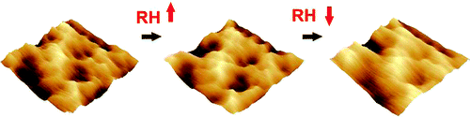

Kelvin force microscopy measurements on films of non-crystalline aluminum phosphate and Stöber silica particles reveal complex electrostatic potential patterns that change irreversibly as the relative humidity changes within an electrically shielded environment. Potential gradients in excess of ± 4 MV/m are found parallel to the film surface, the overall potential adjacent to the samples are negatives. These results verify the following hypothesis: the atmosphere is a source and sink of electrostatic charges in dielectrics, due to the partition of OH⁻ and H⁺ ions associated to water adsorption. Neither contact, tribochemical or electron injection are needed to change the charge state of the ionic solid used in this work.
- An invited review article on the detection of charge and potential excess on solid surfaces was published. This allowed the authors to develop ideas and models for electrostatic charge build-up and also for the existence of complex charge patterns in every insulator – in opposition to widespread ideas on electroneutrality of matter under ambient conditions.

Detection of charge distributions in insulator surfaces
C A Rezende, R F Gouveia, M A Silva and F Galembeck, Journal of Physics: Condensed Matter 21(2009) 263002
Abstract. Charge distribution in insulators has received considerable attention but it still poses great scientific challenges, largely due to current lack of firm knowledge on the nature and speciation of charges. Recent studies using analytical microscopies show that insulators contain domains with excess fixed ions forming various kinds of potential distribution patterns, which are imaged also by potential mapping using scanning electric probe microscopy. Results from the authors’ laboratory show that solid insulators are seldom electroneutral, as opposed to a widespread current assumption. Excess charges can derive from a host of charging mechanisms: local ion excess concentration, radiochemical and tribochemical reactions added to the partition of hydroxonium and hydronium ions derived from atmospheric water. The last factor has been largely overlooked in the literature but recent experimental evidence suggests that it plays a decisive role in insulator charging. Progress along this line is expected to help solving problems related to unwanted electrostatic discharges, while creating new possibilities for energy storage and handling as well as new electrostatic devices.

Following these publications, a post-doc in this group, Telma D. Ducatti, made a new finding: some metals also acquire excess charge when they are exposed to high humidity, in a N₂ atmosphere. This observation is now being developed into a technique for harvesting electricity from the atmosphere according to the claims made in a patent application that received initial deposit in Brazil, in December 2009. The first publication related to this patent claims is now under preparation.

Gas-phase ion chemistry

This has been a major topic in José Riveros´ laboratory for many years now and it is highly relevant to the work on electrostatics mentioned previously. Riveros was an Invited Keynote Speaker in the 18th International Conference on Mass Spectrometry, held in Bremen, Germany, from August 31, 2009, to September 5, 2009. His abstract in this conference and a recent paper abstract are given below:

Some new insights on the gas-phase ion chemistry of Si, Ge, Ti and Sn alkoxides
José M. Riveros
Abstract. This lecture described the work of the last few years carried out in the group that deals with the mechanism of the gas-phase reactions of several nucleophiles with these well-known sol-gel precursors. Work in the gas-phase has allowed us to understand the step by step process of hydrolysis and alcoholysis of these substrates as well as some related reactions. Part of this talk has been accepted as an invited contribution in the European Journal of Mass Spectrometry.

Electron microscopy of soft materials
In 2009 Institute members published a demonstration of a new technique for molecular mapping in complex solids, based on electron-energy-loss imaging in the TEM, using the low-loss range (0-80 eV) that has usually received little attention for the lack of clear understanding on its significance. This paper shows the great advantage of molecular mapping done by EFTEM as compared, for instance, to synchrotron-based techniques using x-rays:

Molecular mapping by low-energy-loss EFTEM imaging
Elisângela M. Linares, Carlos A. P. Leite, Leonardo F. Valadares, Cristiane A. Silva, Camila A. Rezende and Fernando Galembeck*
Analytical Chemistry, 2009, 81 (6), pp 2317–2324
Abstract: The establishment of structure-function relationships in supramolecular systems depends on knowing the spatial distribution of molecules, ions and particles within a complex array. Molecular mapping in the analytical transmission electron microscope, in other words, imaging the spatial distribution of molecular components within nano-structured arrays, is feasible by doing electron spectroscopy imaging (ESI) in the low-energy-loss range, 0-80 eV. This technique was applied to particulate and thin film samples of dielectric polymers and inorganic compounds. Excellent distinction is obtained between areas occupied by various macromolecules and particles clearly showing domains differentiated by small changes in molecular composition and minor differences in elemental contents. Slight changes in the molecules produce intensity variations in molecular spectra that are in turn expressed in sets of low-energy-loss images, using otherwise standard energy filtered transmission electron microscopy EFTEM procedures. The resolution of the molecular maps is in the nanometer range and very close to the bright-field resolution achieved for the same sample, in the same instrument. Moreover, contrast is excellent, even though sample exposure to electron beam is minimal.

This was further explored to observe inorganic particles within complex polymer materials, as in polymer blend nanocomposites. This was made possible thanks to the apparent bleaching of the polymer background, at some specific energy losses due to appearance of isosbestic-like points at some energy losses.
This is now submitted for publication and it will be presented as an invited lecture in the forthcoming 17 International Microscopy Congress in Rio de Janeiro, as the only invited lecture that will be presented in this congress by a researcher working anywhere in Brazil.
Research in this area should be strongly intensified when the new TEM acquired with Fapesp funds within the INCT program starts operating. At present, its installation is nearly complete, the vacuum system is already operating and the high-voltage train will probably go on in the next few weeks. Efforts will be concentrated in three directions: 1) molecular mapping in the low- and high-loss ranges; 2) element-specific tomography; 3) sampling techniques using water-only environments, especially for materials of biological origin.

New routes for making polyphasic soft materials

Past work from this group established procedures for making polymer nanocomposites using only aqueous environments. This was at first surprising and unexpected but it was later understood using a model based on capillary adhesion followed by electrostatic adhesion. The same approach is now extended to the formation of other complex materials by blending hydrophilic and hydrophobic latex polymers. Excellent compatibility is achieved because in the present case it depends on interfacial properties rather than bulk polymer properties. Blending dispersions of common materials like natural rubber, cassava starch, cellulose and clay produces an array of new materials with remarkable mechanical properties as for instance elastic high-modulus materials comparable to vulcanized rubber. This shows that complex materials with high desirable properties can be obtained from common, abundant and renewable raw materials, using recent concepts applicable to soft materials. This is being handled by Dr. Márcia M. Rippel, a researcher in Unicamp supported by a contract from Petrobras, who will present an invited lecture on this subject in the forthcoming 3th International Conference on Functional Materials and Devices next June, in Kuala Terengganu/Malaysia: "Polysaccharides/natural rubber nanocomposites: clay performs as a compatibilizing agent.
A patent application is now being finalized and paper submission will follow.

Inorganic nanotubes

An important development was the consolidation of strict synthesis protocols that led to the production of these materials on a totally reproducible manner. Titanate nanotubes decorated with nanoparticles of CeO₂ were fully characterized using different physico-chemical techniques (FTIR, Raman, XRD and HTEM, SEM). The hybrid system (nanotubes + nanoparticles) showed excellent properties in the photochemical decomposition of dyes used in textile industries.

Decorating Titanate Nanotubes with CeO₂ Nanoparticles

B. C. Viana, O. P. Ferreira, A. G. Souza Filho, C. M. Rodrigues, S. G. Moraes, J. Mendes Filho and O. L. Alves, J. Phys. Chem. C, 113 (47), 2009), pp 20234–20239, DOI: 10.1021/jp9068043

Abstract. In this work, we report the synthesis, characterization, and application of Ce ion-exchanged titanate nanotubes (Ce-TiNTs). The physicochemical properties of these Ce-TiNTs are discussed in comparison with their pure titanate nanotube counterparts. The transmission electron microscope images showed that the Ce-TiNTs have the same morphology as that of pristine nanotubes and their external walls are decorated with cerium oxide nanoparticles. The mechanism of nanoparticle formation is based on the precipitation of Ce ions at the nanotube surface. We observed a red shift of the absorption band edge toward the visible region whose main contribution comes from the Ce ion intercalation. A red shift of vibrational modes associated with metal ion−oxygen interaction was observed and identified as being due to the effect of Ce addition to the lattice as well as the anchoring of CeO₂ nanoparticles to the nanotube wall. We show that this hybrid system is promising for applications in photocatalysis using the blue region of the electromagnetic spectrum. This was demonstrated for photodegradation of Reactive Blue 19 textile dye.

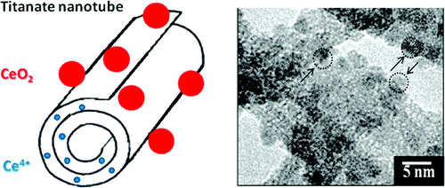

In the case of silver vanadate nanotubes (AgVO₄) it was also possible to obtain two coexisting nanostructures: nanotubes decorated with silver nanoparticles. The study of the biocidal activity of this hybrid system was made against various bacteria, especially those present in local hospital environments. The results are highly promising considering that this material is 10 times more effective against Staphylococcus aureus than the antibiotic oxacillin. These complex materials are now being incorporated in fabrics, plastics and paper in order to take advantage of the biocidsal activity.

Development of nanostructured silver vanadates decorated with silver nanoparticles as a novel antibacterial agent
R.D.Holtz , A.G. Souza Filho , M. Brocchi, D. Martins³, N. Durán and O. L. Alves Nanotechnology ,21, 185102 (2010), DOI: 10.1088/0957-4484/21/18/185102

Abstract. In this work we report the synthesis, characterization and application of silver vanadate nanowires decorated with silver nanoparticles as a novel antibacterial agent. These hybrid materials were synthesized by a precipitation reaction of ammonium vanadate and silver nitrate followed by hydrothermal treatment. The silver vanadate nanowires have lengths of the order of microns and diameters around 60 nm. The silver nanoparticles decorating the nanowires present a diameter distribution varying from 1 to 20 nm. The influence of the pH of the reaction medium on the chemical structure and morphology of silver vanadates was studied and we found that synthesis performed at pH 5.5–6.0 led to silver vanadate nanowires with a higher morphological yield. The antimicrobial activity of these materials was evaluated against three strains of Staphylococcus aureus and very promising results were found. The minimum growth inhibiting concentration value against a MRSA strain was found to be ten folds lower than for the antibiotic oxacillin.

Development of polymer surface modification methodologies

The development of anchored thin polymer layers covalently bonded to the surface of solid materials promises to improve the features of substrate materials by changing the interface behavior. Using this kind of methodologies, we can explore the modified materials in new application using common raw materials, such as the polyethylene, aggregating value to relative cheap materials.

The demonstration of organic routes to build a surface containing polymerization initiators immobilized in the surface of the PE followed a versatile procedure that can also be applied to other polymer substrates. The material allows further modification with vinyl monomers.

Maleimide Immobilized on a PE Surface: Preparation, Characterization and Application as a Free-Radical
Rafael Silva, Edvani C. Muniz and Adley F. Rubira
Langmuir, 2009, 25 (2), pp 873–880
Abstract: Maleimide groups are synthesized on the surface of PE films by means of two different routes, from oxidized and anhydride-grafted PE films. Maleimide groups covalently bonded to the surface of PE film were used as photopolymerization initiators of acrylic acid (AA) and glycidyl methacrylate (GMA). The formation of poly (acrylic acid) (PAA) and poly (glycidyl methacrylate) (PGMA) covalently bonded to the modified PE film surface by the photopolymerization process was demonstrated by ATR-FTIR, gravimetry, and SEM results. The thickness of the polymer layers formed in the polymerization depends on the irradiation time. The PAA layer formed in the polymerization is thinner than 250 nm, whereas that of PGMA in some case is thicker than 3 μm.

Coating of polymers with biomaterials, such as CaCO₃ crystals, is an interesting approach to explore polymers in the biomedical area. A procedure to coat PE with CaCO₃ creates a homogenous surface using a reproducible methodology.

Calcium Carbonate Crystallization on a Polyethylene Surface Containing Ultrathin Layers of Hydrophilic
Rafael Silva, Guilherme M. Pereira, Edvani C. Muniz and Adley F. Rubira
Cryst. Growth Des., 2009, 9 (7), pp 3307–3312.
Abstract: Inorganic/polymer composite materials with controlled phases organized in layers with part of the inorganic material hosted by a hydrophilic polymer layer covalently bound to a hydrophobic polymer layer and the other part of the inorganic material in crystalline phases adsorbed onto the composite surface were prepared. An ultrathin layer of poly(vinyl alcohol) (PVA) and a poly(acrylic acid) (PAA) layer were prepared on polyethylene films, which were used in the crystallization of CaCO3 by a sequential immersion method in a dip-coating process. The number of sequential immersions and the addition of PVA as a possible stabilizer were analyzed. The data suggest that the nucleation and growth of the inorganic material started on the hydrophilic polymer layer, which was composed mainly of PAA, and a mixed inorganic/organic layer was formed. The shape and the proportions of the CaCO3 phases on the composite surface depend on the number of immersion cycles and the addition of PVA.

Cellulose nanowhiskers

The applications of natural fibers in the polymer science have been studied, in the sense of promoting the integration of the polymers production with environmental friendly techniques and raw materials. In this area, the studies of cellulose nanowhiskers have been conduct aim the direct application in the production of polymers composites.

The state of the art in the obtaining, uses and the potential applications of cellulose nanowhiskers was discussed in:

Applications of lignocellulosic fibers in polymer chemistry and in composites
Silva, R.; Haraguchi, S. K.; Muniz, E. C. and Rubira, A. F. Quim. Nova 2009, 32 (3), 661-671
Abstract: The use of lignocellulosic fibers and their constituents, as raw materials in the production of polymeric and composite materials, represent an exceptional opportunity of sustainable technological development. In the present report works that discuss promising alternatives of obtaining and use of materials such as cellulose, hemicellulose, lignin, cellulose nanocrystals and biocomposites were revised. The advance in the use of biomass can be, in a near future, capable of going beyond the application difficulties of these vast materials, especially in relation to the economical unviability, by the production of high performance polymeric and composite materials. This advance would represent a higher profitability to some areas of agrobusiness, especially the sector of biofuels, which produces elevated amounts of biomass waste.

Actually, our efforts in the development of the obtantion and use of Cellulose nanowhiskers are concentrated in two research projects; each one is carried out by a Ph.D student.

Polyurethanes and polythionocarbamate Hiberbranched grafted on cellulose nanocrystal obtained of sugarcane bagasse.

Shirani Haraguchi, a second year Ph.D student, demonstrated that different characteristics of cellulose nanowhiskers obtained from sugarcane bagasse can be controlled by the inorganic acid and the hydrolysis process condition used, so the process can be chose to match with the necessary characteristic to each composite. In the polymerization process, the utilization of ultrasonic radiation has been successful results exploring the glycerol as monomer in the production of polyurethanes and polythionocarbamate hiberbranched. The set up of the polymerization process has been improved to reach the necessary condition in the obtaining of homogeneous composites.

Surface modification of cellulose nanowhiskers

Cristiane Spagnol, a first year Ph.D student, has studied the development of methods for the modification of cellulose nanocrystal obtained from cotton. The aim of the project is to prepare materials with suitable properties to the application in the composite production and also in the production of nanoparticles containing special vesicles to encapsulate and release drugs and nutraceutics. The vesicles production has been studied by Daniele Martins, a pos-doc grantee. The modification of the nanowhiskers surface was realized with different anhydrides: maleic; succinic and acetic. The results of the chemical analyses (FTIR and NMR) proved the modifications and the studied of the suspension stability demonstrated the variation the interaction of the cellulose nanowhiskers. The materials modified with maleic anhydride and succinic anhydride show interesting suspension stability that vary in function of the pH of the aqueous medium. In both cases, the nanowhyskers have great suspension stability in the basic medium in function of the carboxylic acid groups present on the surface of the crystals compared to acid or neutral medium.

Theoretical investigation on the mechanism of light alkanes aromatization over gallium-containing zeolites.

The introduction of metallic species, such as Pt, Zn, Ga, etc. into H-MFI zeolites increases the rate and selectivity of aromatization reactions. The use of gallium seems to be preferable for industrial applications because of the higher stability of the Ga exchanged zeolites under the operating conditions. Various commercial processes using Ga/H-MFI catalysts, such as the Cyclar from UOP and BP, Aroforming from IFP and Salutec and Z-forming from Mitsubishi and Chiyoda have been developed to transform liquefied petroleum gas (LPG) into benzene, toluene and xylenes hydrocarbons (BTX) with simultaneous formation of large amounts of hydrogen, which is, by itself, a valuable product. Due to the importance and usefulness of these processes, as well as the complexity of the reactions involved, Ga/H-MFI systems have drawn much attention as target for both experimental and theoretical research. Nevertheless, many aspects of the mechanism of these reactions and of the nature of the active sites are yet to be ascertained.

We have been conducting high level calculations on cluster models of the Ga/H-MFI zeolites in order to elucidate, at the molecular level, the nature of the active site as well as the mechanism of the aromatization reaction. These studies are also performed with the purpose of giving support to the experiments being conducted by other members of INOMAT. In fact, the interaction between the theoretical and experimental groups has proven to be extremely fruitful.

The main achievements so far in this line are: a) the aromatization reactions requires a bi-functional catalyst with both active sites on the same channel, the Ga site acting as the dehydrogenation center and the Brönstead site as the chain propagator; b) the dehydrogenation reaction via the GaH₂⁺ site may proceed according to two different mechanism: small linear alkanes follow a 3-step mechanism while the branched ones follow a 1-step concerted mechanism. A paper containing a detailed discussion of all the calculations will be soon submitted to the Journal of Physical Chemistry C.

Theoretical investigation of the reaction of light alkanes over Ga-Containing zeolites
Marcio Soares Pereira, Alexander Martins Silva, Marco Antonio Chaer Nascimento
Abstract: The dehydrogenation reaction of light alkanes (ethane, propane, n-butane and i-butane) in gallium containing zeolites was studied using density functional theory (DFT) and a non-framework gallium species in the dihydridegallium ion form (GaH₂⁺). The effect of the cavity was incorporated using a cluster with 22 tetrahedron atoms (T22) to model the zeolite. Two different mechanisms were considered when examining the dehydrogenation reaction of ethane: a 3-step mechanism and a 1-step concerted mechanism. The energy profile of the 3-step mechanism is somewhat changed by the incorporation of the cavity effect. On the other hand, no significant changes are observed for the concerted mechanism. The activation energy for the 3-step mechanism is still lower than that of the concerted one by 7 kcal/mol for ethane, but for the bulkier substrates the 1-step concerted mechanism becomes more favorable.
Investigation of the mechanism of light alkane aromatization on gallium-modified ZSM5 zeolite catalysts

Aromatization of light alkanes (methane to butane) has been thoroughly studied since the 90´s, because of its economical and strategic importance in terms of the exploitation of natural gas resources and valorization of light hydrocarbons obtained in petroleum refining. Commercially, these reactions using gallium-modified zeolitic catalysts of ZSM5 type are named “Cyclar” process, and were developed jointly by UOP and British Petroleum (BP). Recently the interest in studying these catalysts has been renewed, due to the growing importance of GTL (Gas to Liquid) technologies all over the world. Despite considerable research in the past decades, many doubts still remain related to the functioning of the gallium-modified catalysts, mainly with respect to the nature of the gallium active species and the importance of zeolitic acid sites in alkane activation. This project aims to help elucidate these questions.

Main achievement in this line was the proposition of a structure for the gallium active site and a sequence of reactions for the alkane activation mechanism in these catalysts. So far, the project originated a publication at Journal of Physical Chemistry C ( V. de O. Rodrigues, J.-G. Eon and A. C. Faro, Jr., J. Phys. Chem. C, 2010, 114 (10), pp 4557–4567) and the completion of a PhD Thesis by Victor de Oliveira Rodrigues.

Study of Propane Aromatization Reactions on Gallium- Modified HZSM5 Catalysts
V. O. Rodrigues, PhD Thesis, Instituto de Química, UFRJ, 2010

Abstract: Ga/HZSM5 catalysts with 2, 3 and 4 wt. % gallium were prepared by incipient wetness impregnation of HZSM5 zeolites with SAR values of 24 and 35 and a silicalite. The modified zeolites were submitted to two consecutive treatments of reduction in hydrogen and reoxidation in air. Catalysts were characterized by physical adsorption of nitrogen, XRF, XRD, MAS NMR fo 29Si and 27Al, TPR, in situ and ex situ X-ray absorption spectroscopy, in situ DRIFTS and FTIR in the structural region, in the OH stretching region and in the region of skeletal vibrations of adsorbed pyridine. Catalytic activity and selectivity were measured in propane conversion reactions with and without hydrogen at 703 K. Catalyst activation was followed using a pulse method at this same temperature. Information was obtained on the mechanism of the aromatization reaction and it was proposed that propane activation and dehydrogenation reactions occur at gallium sites, while cyclization and oligomerization reactions occur at the zeolites acid sites. A structure for the gallium active site and a sequence of reactions for the activation mechanism in these catalysts were proposed based on the in situ experiments results. Positive correlations were found between reducibility, Lewis acidity and the dispersion of
the gallium species present in the catalysts on the oxidized form. The high Lewis acidity of the highly dispersed gallium oxidic species facilitates the hydrogen dissociation and gallium reduction. Moreover a good linear correlation between propane aromatization activity and the product of the Lewis and Brønsted acid site concentrations in the catalysts oxidized form, indicating the need for both sites at the aromatization reaction.

Polymeric Nanocomposites with High Performance Flame Retardancy

The research line on intumescent formulations for flame retardant polymeric materials has shown progress in the direction of determining the main synergistic agents structural characteristics that would be responsible for the synergy effect observed. Organophilic clays with d-spacings from 11.4 to 22.9 Angstrons presented the same strong synergy effect, as shown on the publication:

Influence of clays on the flame retardancy and high temperature viscoelastic properties of polymeric intumescent formulations
Simone P.S. Ribeiro, Luciana R.M.Estevão, Celeste Pereira, João Rodrigues and Regina S.V. Nascimento
Polymer Degradation and Stability 94 ( 2009) 421-431
Abstract: A natural Brazilian montmorillonitic clay was submitted to organophilization treatments to evaluate the effect of these treatments on the flame retardancy potential of polymer composites containing an intumescent ammonium polyphosphate and pentaerythritol formulation. An ethylene and butyl acrylate copolymer was used as polymeric matrix. Natural or organophilic clays were added both to the pure polymer and to the polymer containing the intumescent mixture. The influence of these mineral fillers, and of their organophilization treatments, on flame retardancy was investigated by thermogravimeric analysis (TGA), limiting oxygen index (LOI), UL-94 rating standard, heating microscopy, rheological measurements and cone calorimetry. The results show that these inorganic additives have a synergist effect in the polymeric composite containing the intumescent formulation

However, the synergy effect is lost when d-spacings are increased up to 31.5 Angstrons, as shown through the paper submitted as follows:

Effect of basal spacings of clays on fiire retardant properties of polymeric materials by thermal analysis
Ribeiro S.P.S., Estevão, L.R.M., Novak, Cs., Nascimento, R.S.V.
Journal of Thermal Analysis and Calorimetry
Abstract: In this work, samples of poly (ethylene-co-butyl acrilate) (EBA-30) containing an intumescent formulation with ammonium polyphosphate (APP) and pentaerythritol (PER) as well as clays with different basal spacings had their flame retardant properties evaluated by thermogravimetric analysis (TGA), differential thermal analysis (DTA) and by heating microscopy. Samples without the polymeric matrix were also analyzed in order to observe the occurrence of any interaction between the clays and the intumescent formulation. It was observed by thermal analysis that the basal spacings of the clays have a strong influence on its synergistic effect on the intumescent formulation studied.

Nanopharmaceuticals for biomedical applications

One of our topics in the Institute is the production of polymeric nanoparticles, its loading with actives (e.g. antibiotics, antitumoral and cosmetics). This research involved undergraduate, master and Ph.D students. The main results obtained in this area are:

It has been demonstrated that tumoral cells have a higher uptake of ascorbic acid compared to normal cells and this characteristic was used to internalize antitumoral to cancer cells through polymeric nanoparticles capped with ascorbic acid or cyclodextrin encapsulation. This was part of undergraduate research of Dorival Martins and Lucas Frungillo (from Biology Institute) and of Priscyla D. Marcato and Zaine Teixeira Ph.D students (IQ-UNICAMP) that were approved in July 2009 and November 2019, respectively. A collaborative research with Japan and Italy was also achieved. These were published as follows:

Antitumoral activity of L-ascorbic-acid -poly-D,L-(lactide-co-glycolide) nanoparticles containing violacein.
Martins, D., Fungillo, L., Anazzati, M.C., Melo, P.S. and Durán, N.
Intern. J. Nanomed. 5, 77-85 (2010).

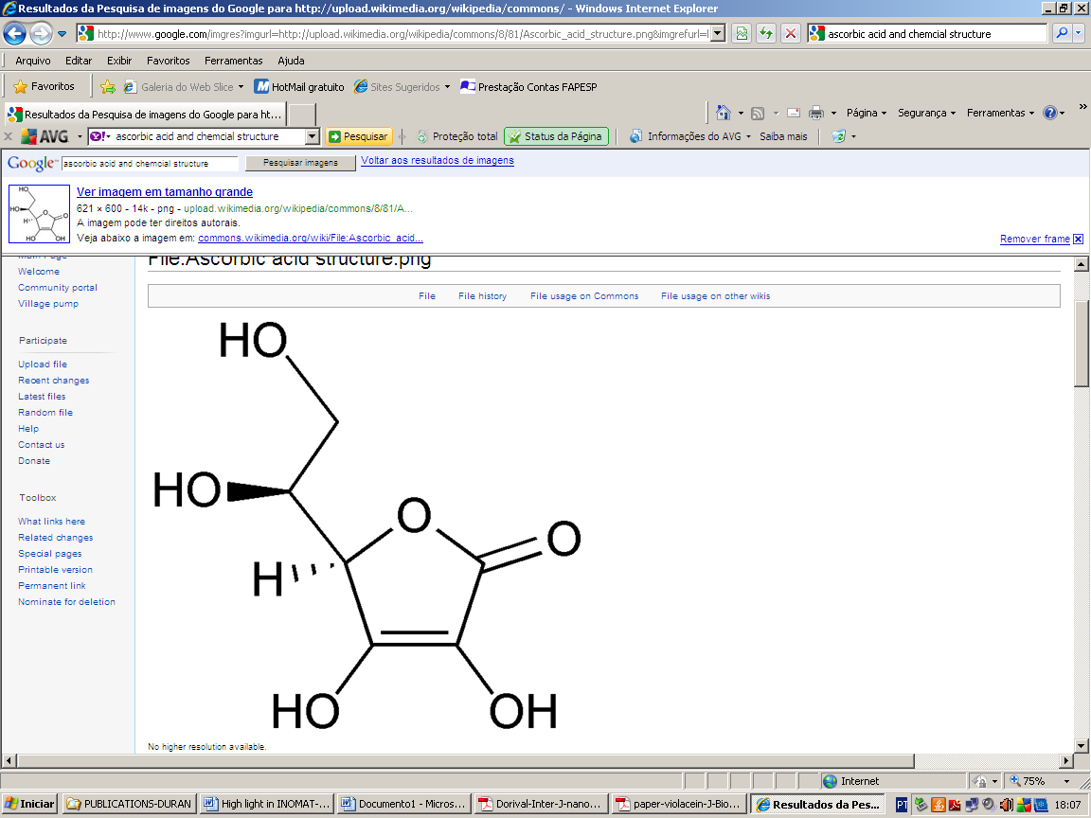
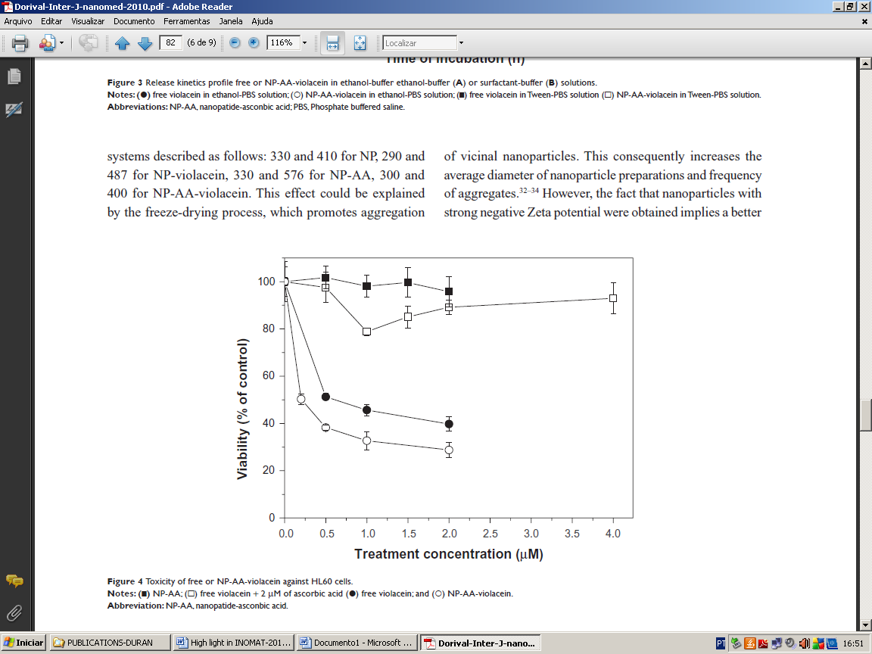
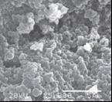
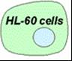
PLGA

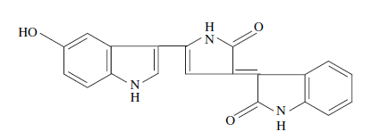

VIOLACEIN

Toxicity of free or NP-AA-violacein
against HL60 cells.
Notes: (■) NP-AA; () free violacein/
2 μM of ascorbic acid () free violacein;
and () NP-AA-violacein.
Abbreviation: NP-AA, nanopatide-ascorbic
acid.

Abstract. It has been demonstrated that tumoral cells have a higher uptake of ascorbic acid compared to normal cells. This differential characteristic can be used as a way to improve the specificity of antitumoral compounds if combined with polymeric drug delivery systems. The aim of this study was to prepare, characterize and evaluate the antitumoral activity of nanoparticles of PLGA loading the antitumoral compound violacein and capped with L-ascorbic acid against LH-60 cells. In addition, this system was observed to be 2 × more efficient as an antitumoral compared with free violacein.

Other publicatios in this area:

Colorectal cancer chemoprevention by β-cyclodextrin inclusion compounds of
auraptene and 4´-geranyloxyferulic acid.
Tanaka, T., De Azevedo, M.B.M., Durán, N., Alderete, J.B., Epifano, F., Genovese, S., Tanaka, M., Tanaka, T. and Curini, M.
Int. J. Cancer:. 126, 830-840 (2010).

Another important topic in this Institute is the technical aspects of the nanocrystal production, where the morphological aspects, the market relevance are discussed. This is part of Ph.D. Thesis of Marcela Durán (Med.Faculty-UNICAMP) which is in progress. This was published as follows:

Nanocrystal Technologies in Pharmaceuticals.
Durán, N., Durán, M. ,Tasic, L. and Marcato, P.D.
Quim. Nova, 33, 151-159 (2010).

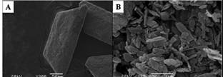
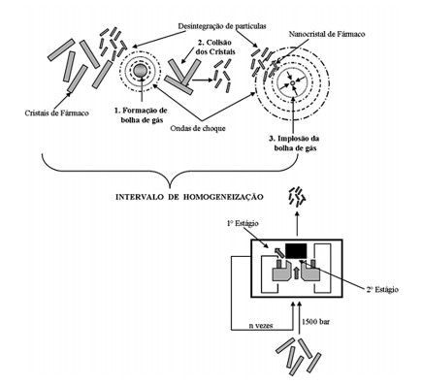 High pressure homogenization of P-MAPA
in tensoactive: A) before ( x 300) and B)
after (x 25000)
Scheme of the high pressure
homogenization. Region 1: implosion,
Region 2: boiling.

Abstract. The use of poorly water soluble molecules in pharmaceutical area has grown. Since these molecules exhibit low oral bioavailability, they are not used in intravenous administrations. This mini-review describes technical aspects of the nanocrystal production, morphological aspects (polymorphisms), the market relevance of the nanocrystals products that are already in clinical phase or at the market, as well as, perspectives for the near future.

Metallic nanoparticles in biological applications

Metallic nanoparticles are important as pharmaceutical carriers. In this direction the importance of nitric oxide donors are escential in the medical treatment of many diseases. This was part of post-doctorate of Dr. Amedea B. Seabra in Canada and collaboration with our group. The silver nanoparticles and its biological activities is a strong research area in this Institute and is part of Ph.D. Thesis of Priscyla D. Marcato, approved in November 2009. This area is an active collaboration with Amravati University in India. Magnetite nanoparticles was studied by a Ph.D. student, Roberto Valenzuela (Fac. Pharm. Univer. De Concepcion-Chile), under a collaborative program with Chile. Theses research were published as a review as follows:

Nitric oxide-releasing vehicles for biomedical applications.
Seabra, A.B. and Durán, N.
J. Mater. Chem., 20, 1624–1637 (2010).

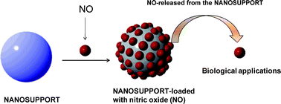
The origin of the nitric oxide donors, their carrying and release to exert its biological activity.

Abstract. Nitric oxide (NO) is involved in several physiological processes, such as the control of vascular tone, the inhibition of platelet aggregation, smooth muscle cell replication, the immune response, and wound healing processes. Thus, there is great interest in developing NO-releasing drugs and in matrices which are able to stabilize and release NO locally and directly in different tissues. In this work, the current state-of-the-art approaches to NO-release from nanomeric materials, their preparation, and promising biomedical applications are reviewed. Such materials, comprised of dendrimers, liposomes, metallic and silica nanoparticles, polymeric micro and nanoparticles, semiconductor quantum dots, carbon nanotubes, and nanoporous solid materials exhibit exceptional potential in directly delivering NO in a controlled spatial and temporal manner with superior biocompatibility for pharmacological applications.

Mangiferin encapsulated in chitosan/pectin particles for the treatment of mastites in cows and sheep.

Mangiferin is obtained from mango fruits that are very abundant in Brazil. It possesses many pharmacological activities: antiviral, analgesic, antitumor and it protects the stomach mucosa. It is water-insoluble and its use benefits from encapsulation for controlled release, in nutraceutic formulations. Encapsulated mangiferin is thus a promising tool for prevention of mastitis in cows and sheep, that is a major cause for decreased milk production in Brazil.

Abstract. Chitosan-coated pectin beads: Characterization and in vitro release of mangiferin
José Roberto R. de Souza, Jose Ivan X. de Carvalho, Maria Teresa S. Trevisan, Regina C.M. de Paula, Nagila M.P.S. Ricardo, Judith P.A. Feitosa
Food Hydrocolloids 23 (2009) 2278.A b s t r a c t: Microspheres of low degree of esterification (DE) pectin with calcium and the same sphere coated with chitosan (PCaC) were prepared. The spheres have diameters in the range 650–680 mm. The layer of chitosan is about of 5–15 mm thick. To obtain firm and stable PCaC beads, chitosan was reacetylated. Two different degrees of acetylation, giving PCaC50 and PCaC80 were adopted. The beads were characterized by FTIR, SEM and swelling measurements. Mangiferin was loaded in PCaC reacetylated in two different ways: by addition in pectin solution (Mp) and by addition in CaCl2 solution (Mc). The yield in producing the beads, the efficiency in encapsulation and the content of mangiferin in beads were determined. A swelling kinetics study was done in simulated gastric fluid (SGF, pH 1.2) and in simulated intestine fluid (SIF, pH 7.4). The release of mangiferin from the beads was performed in SGF followed by the release in SIF. Based on the yield and efficiency in encapsulation the best bead was found to be PCaC50-Mp. The highest release (7.8 mg of mangiferin/g of bead) was achieved by the PCaC50-Mc. For all beads more bioactive was released in SGF than in SIF.

Preparation and characterization of blends and polymeric nanocomposites

The discovery of the polymeric nanocomposites and supertough blends are clearly the greatest advances in the development of new polymeric materials. The association of supertough blends and nanocomposites allows combining high impact resistance and ductility with high stiffness, tensile strength and barrier properties. In order to develop supertough blends and nanocomposites, efforts are concentrated in research works, especially involving clays and nanotubes, which have already been published:

High molar mass silicone rubber reinforced with montmorillonite clay masterbatches: Morphology and mechanical properties
Manuela L.Q.A. Kaneko, Rafaelle Bonzanini Romero, Maria do Carmo Gonçalves,
Inez V.P. Yoshida
European Polymer Journal, 2010, available online
A b s t r a c t: Rubber composites were obtained from natural (MT) or organomodified (O-MT) montmorillonite clay masterbatches and high molar mass poly(dimethylsiloxane)-gum (PDMS). The masterbatches were prepared by compounding MT or O-MT with a siloxane–polyether surfactant. The rubber composites were characterized by X-ray diffraction, small angle/wide angle X-ray scattering, scanning and transmission electron microscopies and tensile tests. The results showed that masterbatch compounding with O-MT improved the dispersion of this clay into the PDMS matrix. The morphology of the resulting composite showed a combination of intercalated and partially exfoliated clay layers with occasional clay aggregates. The addition of only 5 phr of O-MT into the PDMS matrix, via masterbatch compounding, improved the tensile strength as much as that obtained with the composite filled with 30 phr of O-MT clay prepared by the direct addition of the clay to PDMS. Moreover, the elongation at break was improved by at least 126%.

II) Innovation, cooperation with industrial and other companies, knowledge transfer

Activity in this area is strong and growing. The list of companies and the types of activities involved are listed beneath. Its comparison to analogous reported data from leading national laboratories in Brazil shows clearly the leading role of Inomat in transforming new scientific knowledge in products and processes, in Brazil.
A list of companies that were connected to Inomat researchers ativities during the year 2009 or are currently holding some type of cooperative activity is the following:
(Legend: CONS: consulting; PC: joint R&D projects; LIC: patent licensee; SE: research service.)

Oxiteno S/A, Mauá - SP (CONS)
Celulose Irani S/A, Porto Alegre - RGS (CONS)
Nutec – Núcleo de Tecnologia do Estado do Ceará, Fortaleza – CE (CONS)
Natura Ltda, Cajamar - SP (CONS)
Laboratório Evidence, Fortaleza –CE (CONS)
Petrobras S/A, Rio de Janeiro - RJ (PC, CONS)
Montana Química S/A, São Paulo - SP (CONS, SE)
Johnson & Johnson, São José dos Campos - SP (CONS, SE)
Embrapa Agroindustria Tropical, Fortaleza – CE (PC)
Petrobras S/A, Salvador – BA (PC)
Braskem S/A, Salvador - BA (PC)
Inmetro, Rio de Janeiro - RJ (PC)
Souza-Cruz S.A./British American Tobacco, Rio de Janeiro – RJ (PC)
Embrapa – Empresa Brasileira de Pesquisa Agropecuária, Rio de Janeiro - RJ (PC)
Cristália Produtos Químicos Farmacêuticos Ltda, Itapira - SP (PC)
Contech Produtos Biodegradáveis LTDA, Valinhos – SP (PC, LIC)
Bunge Biphor LLC, White Plains, NY - EUA (PC, LIC)
Bunge Participações, São Paulo - SP (PC, LIC)
Quattor Petroquímica S/A, Camaçari - BA (SE)
Pirelli Pneus Ltda, São Caetano - SP (SE)
Globe Química Ltda, Cosmópolis – SP (SE)
Citrosuco S/A, Matão - SP (SE)
Araújo Engenharia e Integr. em Equipamentos Ind. SS, Vinhedo - SP (SE)
Indaia Brasil Águas Minerais, Fortaleza – CE (SE)
Agripec Química e Farmacêutica, Maracanaú – CE (SE)
Cesde - Indústria e Comércio de Eletrodomésticos Ltda, Maranguape - CE (SE)
Bracol – Indústria de Couros Ltda, Cascavel – CE (SE)
Bermas - Indústria e Comércio Ltda, Maracanaú - CE (SE)
Petropar Embalagens S/A, Horizonte - CE (SE)
Esmaltec S/A, Maracanaú – CE (SE)
Camy Plast Br – Indústria e Comércio de Plásticos Ltda, Fortaleza – CE (SE)
Carnaúba do Brasil, Fortaleza – CE (SE)
Blausigel – Indústria e Comércio Ltda., Cotia - SP (SE)
GEA Niro Soavi Brazil, Campinas - SP (SE)
Orbys Desenvolvimento de Tecnologia de Materiais Ltda, São Paulo - SP (LIC)
IQT S/A, Taubaté - SP (LIC)

Inomat members are involved in a number of “Subvenção Finep” grants to various companies, as follows:

Dublauto Ind. e Com. Ltda, Bariri – SP (SUB), "Incorporação de propriedades da nanotecnologia em materiais têxteis (palmilhas e forros) para calçados", Finep/ MCT, 2008 - Atual

Oxiteno S/A Indústria e Comércio, Mauá -SP, "Desenvolvimento de catalisador para produção do monômero estireno", 2008 - Atual

Plaspet Reciclagens Maringá Ltda, Maringá – PR, “Laboratório de Inovação Tecnológica em Macromoléculas (LABITEM)”, 2006 - Atual

Petrobrás S/A, Rio de Janeiro, RJ, "Desenvolvimento de catalisadores em escala piloto para a reforma de gás natural", 2005 - Atual

The large number of companies interacting with Inomat researchers shows that this Institute uses many strategies to transfer knowledge and to shorten the path from the research laboratory to the market. The large number of industry partners is an evidence of the success of these strategies.
On the other hand, Inomat researchers receive a powerful and continuous feedback from industry professionals that contributes to continuously define relevant focuses for their work.
Even research services that are often viewed as a second-class kind of activity with little intellectual challenge have shown a stimulating effect on students and researchers. For instance, a student working to improve or create microscopy methodology is often impressed by the reaction of industry personnel when they receive a set of micrographs and eagerly discuss them. This has an invaluable positive effect on the student appreciation of his work.

III) Education

Inomat members are actively involved in education, both at the undergraduate and graduate school level and in science education improvement projects.
Thirteen doctorates and twelve M.Sc. theses were approved, and the students’ work makes a significant part of the extensive publications list presented in this report.
Inomat Ph.D. students and post-docs were encouraged to participate from many international conferences. An interesting case is that of Rubia Gouveia, who was invited to give an invited lecture in an Binational (Argentina-Brazil) School of Nanotechnology, in Buenos Aires. Her topic was “Electric probe scanning microscopy”.

IV) Diffusion of knowledge
Inomat members are actively engaged in making knowledge available to large groups of persons. The strategy used by Institute members is the association to other existing activities and organizations to achieve synergism and maximum covereage, whenever possible.
Main results are:
1- Twenty-seven LQES News bulletins were posted in the period of 2009/2010 (april). Number of average downloads is 24,700/month. The Bulletin LQES News is hosted at the site of Laboratory of Solid State Chemistry in Unicamp and is sent to by e-mail to over 4,560 subscribers, with news in science, technology and innovation, with an emphasis in nanotechnology, materials, environment, energy, etc. Over 160 stories were presented. The LQES News is replicated in sites from several universities, colleges, professional associations and government agencies. A typical page is copied below.


ISSN 1677-5058
O Boletim Eletrônico LQES NEWS é uma publicação eletrônica quinzenal gratuita, do Laboratório de Química do Estado Sólido, do Instituto de Química da UNICAMP, Campinas, São Paulo, Brasil, enviada aos assinantes do LQES Website. Veicula Notícias de C&T&I, Novidades do LQES e novas incorporações no Site - dirigidas aos aderentes -, em link direto com o LQES Website.
Caso tenha dificuldade com a leitura do LQES NEWS, clique AQUI.
_____________________________________________________________________
* Novidades de C&T&I e do LQES
Grafeno para resfriar computadores ?
Pesquisadores americanos e franceses conseguiram melhorar a dissipação de calor nos componentes eletrônicos usando este material.
Turbina marinha na Amazônia.
Empresa escocesa testa dispositivo concebido para captar energia em rios de fluxo lento.
Nanotubos de carbono ionizam individualmente átomos ultrafrios.
Pesquisadores da Universidade de Harvard (EUA) observaram a captura e ionização de átomos individuais perto da parede lateral de um único nanotubo.
Nanotecnologia : uma revolução em marcha.
A National Science Foundation, dos Estados Unidos, prediz que, em 2015, a nanotecnologia produzirá a metade da gama de produtos farmacêuticos.
Imitando os processos naturais do corpo humano.
A nanotecnologia é usada para descobrir um meio de imitar os processos fisiológicos naturais do organismo, notadamente a criação de vasos sanguíneos.
Nanotecnologia chega à casa dos consumidores brasileiros.
Empresas como Biolab, Natura e Embrapa investem em inovação no setor e patenteiam novas tecnologias. Aplicações vão de cosméticos a roupas, passando por equipamentos esportivos.
Divulgação
Resíduo é matéria-prima para sustentabilidade no mercado.
Com recursos da Finep e, em parceria com universidades, a Cetrel pesquisa reaproveitamento dos rejeitos industriais. A empresa investe 7% do seu faturamento em inovação tecnológica.
Nota do Webmaster
Já está em funcionamento no LQES Website o sistema de busca Google do conteúdo do site. Com esta ferramenta você pode conhecer ainda melhor todo o material disponibilizado no site. Para isso, acesse a página principal (http://lqes.iqm.unicamp.br) e coloque a palavra-chave em LQES Busca. O próximo passo é clicar, daí, é só ver os resultados !
Maria Isolete Alves (MIA) – Managing Editor
Oswaldo Luiz Alves (OLA) – Scientific Editor
Antonio Gomes de Souza Filho (AGS) – Invited Editor
Italo Odone Mazali (IOM) – Invited Editor
Paulo Amaral (PA) – Webmaster
LQES NEWS - ISSN 1677-5058 – Ano IX – nº. 193, 18 de abril de 2010.
© 2001-2010 LQES
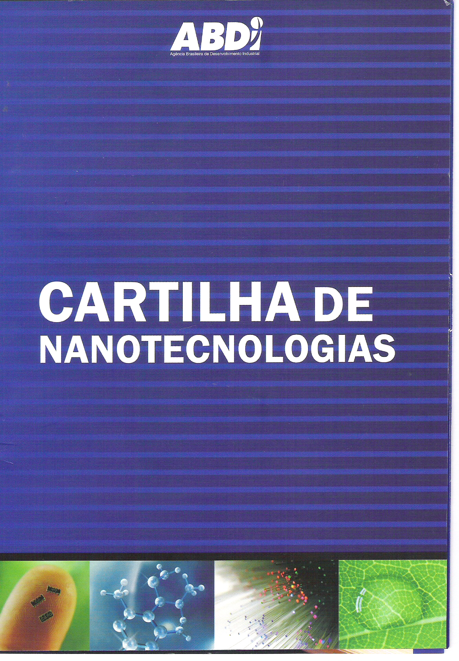
2- Participation of Inomat researchers in the preparation of a Nanotechnology primer, in cooperation with ABDI (Brazilian Agency for Industrial Development). The pilot edition is now available and a large-scale edition should go in print shortly. This publication aims to introduce nanotechnology to a large audience trying to show its historical evolution, the ways to make nanotechnology, products on the market that incorporate this technology in Brazil and abroad, the risks and benefits. Bellow is showed the preformatted cover.

3- Presentation of 51 talks in schools and universities, professional associations, entrepreneurial organizations. In these talks were presented the novel scientific and technological results obtained in various Inomat projects, but also lectures of general nature concerning to nanotechnology, advanced materials, electrostatic and environmental remediation. It is estimated that these activities have been engaged audiences exceeding 2500 people.
4- Inomat webpage that was open to public access in October 2009 and gives detailed information on this institute.

Materials
The main Internet materials are the Inomat webpage and the LQES News Bulletins. One representative display of each is shown beneath.

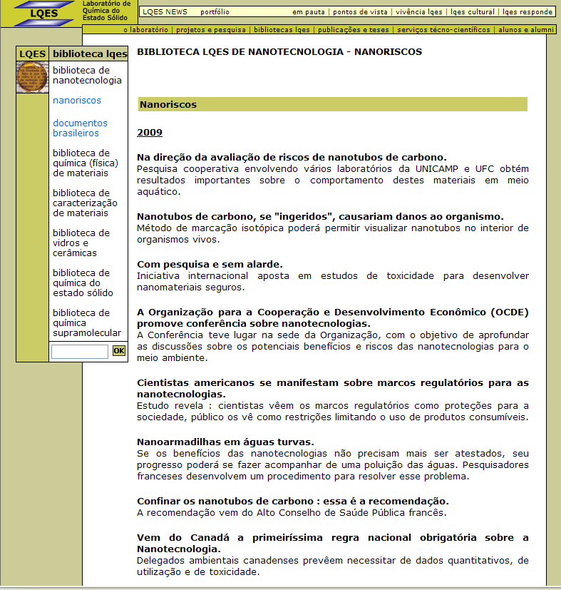

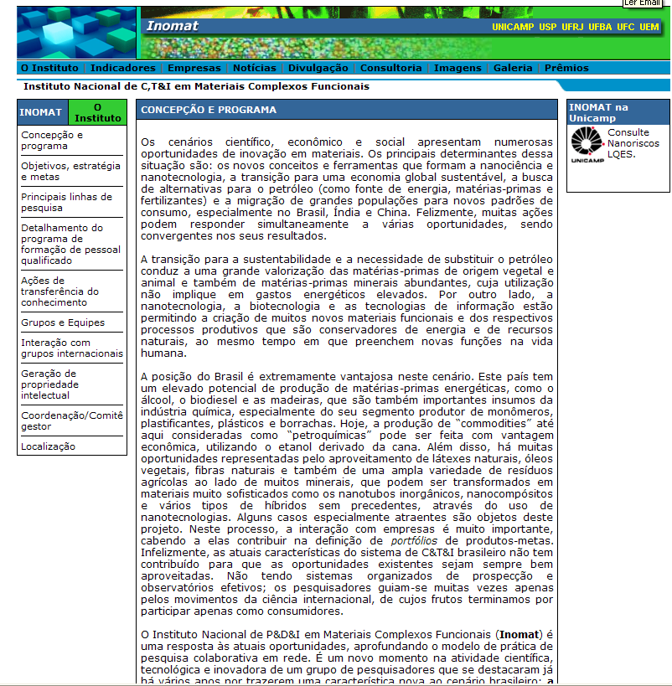

Project Personnel

The research groups networked in this Institute are listed below, under the name of each group coordinator. Legend: PQ: Researcher, post-doc level but supported by specific project grant; PD: post-doc supported by a fellowship from this project or other source; PG-D: doctorate student; PG-M: M.Sc. student; TS: graduate or Ph.D. level technician; TM: technician; IC: undergraduate student; ES: undergraduate trainee.

Grupo de Morfologia e Topoquímica de Sólidos - UNICAMP
Coordenador: Prof. Fernando Galembeck
fernagal@iqm.unicamp.br

Ana Aparecida dos Santos
Nicodemos (TM)
Maria do Carmo Vasconcelos Medeiros da Silva (TM)
Carlos Alberto de Paula Leite (TS)
Camila Alves de Rezende (PD)
Juliana da Silva Bernardes (PD)
Telma Rie Dói Ducati (PD)
Rubia Figueredo Gouveia (PG-D)
Lucimara Lopes da Silva (PG-D)
Leandra Pereira dos Santos (PG-D)
Ziarat Shah (PG-D)
Thiago Augusto de Lima Burgo (PG-D)
Márcia Maria Rippel (PQ)
Yara Csordas (PQ)
Luis Henrique Simões (IC)
Helison Rafael Pereira dos Santos (ES)
Fabiana Cunha Giora (ES)

Laboratório de Química do Estado Sólido - LQES - UNICAMP
Coordenador: Prof. Oswaldo Luiz Alves
oalves@iqm.unicamp.br

Italo Odone Mazali (PQ)
Fernando Aparecido Sigoli (PQ)
Antônio Gomes de Souza Filho (PQ)
Natália Valenga Parizotto (PQ)
Amauri Jardim de Paula (PG-D)
Diego Stéfani Teodoro Martinez (PG-D)
Carolina Martins Rodrigues (PG-D)
Rafaella Oliveira do Nascimento (PG-D)
Raphael Dias Holtz (PG-D)
José Mateus Dias Neto (PG-M)
Paulo Sérgio do Amaral (TS)
Artur Madeira (IC)
Renan Pessolano Almeida (IC)
Vitor Lacerda Mauricio (IC)
Juliana Martins de Souza e Silva (PQ)
Fernando José Volpi Eusébio de Oliveira (PQ)
Camila Marchetti Maroneze (PG)
Elias de Barros Santos (PG-D)
Luiz Pereira da Costa (PG-D)
Mathias Strauss (PG-D)
Jaqueline Honório
Fabiana Cristina Andrade Corbi (PG-D)
Rafael Di Lázaro Gaspar (PG-D)
Ernesto Rezende de Souza (PG-D)
João Henrique Lopes (PG-D)
Everson Thiago Santos Genôncio da Silva (PG-M)
Raphael Rodrigues Lages (PG-M)
André Luiz Beraldo Brunozi (IC)
Bruno Oshiro Shimojo (IC)
Cristine Santos de Oliveira (IC)
Danilo Mendes Dolazza (IC)
Diego Costa Ferreira Moreira (IC)
Diego Roberto da Silva (IC)
Emille Martinazzo Rodrigues (IC)
Nathália Medeiros Carneiro (IC)
Ariadne Tückmantel Bido (IC)
Renata Sigrist (TM)
Gisela de Aragão Umbuzeiro (PQ)

Grupo de Pesquisa em Polímeros - UNICAMP
Coordenador: Profa. Maria do Carmo Gonçalves
maria@iqm.uniccamp.br

Maria Isabel Felisberti (PQ)
Márcia Maria Favaro (PD)
Juliana Aristéia de Lima (PD)
Jonathan M. Bergamaschi (PG-D)
Patrícia Fernanda Andrade (PG-D)
Larissa Reis Brandão (PG-D)
Fabiana Pires Carvalho (PG-D)
Miguel Chavez Gutierrez (PG-D)
Sebastián Gómez Robles (PG-D)
Caio Augusto Pinotti (PG-M)
Heitor Fernando Nunes de Oliveira (PG-M)
Rafael Bergamo Trinca (PG-M)
Álvaro Luiz Gomes (PG-M)
Gustavo Vandromel Rodrigues (IC)
Ariane Cagliari Sarzi (IC)
Helton Pereira Nogueira (PG-M) (IC)
Rafael Pissinati Perez (IC)

Grupo de Fotoeletroquímica e Conversão de Energia - UNICAMP
Coordenador: Profa. Claudia Longo
clalongo@iqm.unicamp.br

Haroldo Gregório de Oliveira (PG-D)
Reginaldo da Silva Santos (PG-D)
Bruno Honda de Oliveira (PG-M)
Everson Thiago Santos Grôncio da Silva (PG-M)
Edmundo Bello (IC)
Paula de Almeida (IC)
Marina Novelli Oliveira (TM)

Grupo de Estudos em Cinética e Catálise - GECCAT- UFBA
Coordenador: Profa. Maria do Carmo Rangel Santos Varela
mcarmov@ufba.br

Alexilda Oliveira de Souza (PQ)
Amalia Luz Costa (PQ)
Ana Cláudia Lima de Jesus (IC)
Ana Paula Bispo Gonçalves (IC)
Ana Paula de Melo Monteiro (PG-D)
André Rosa Martins (PG-M)
Antonia Soares de Oliveira (TS)
Bianca Borges da Silva (IC)
Caio Luis Santos Silva (PG-M)
Camila Silva de Brito (IC)
Cláudio Taranto (PG-M)
Cristiane Martins Veloso(RD)
Danns Pereira Barbosa(PG-D)
Diego Rodrigues de Crvalho(PG-M)
Eva Bárbara Sá Teles(PG-M)
Genebaldo Sales Nunes(PQ)
Guillermo Paternina Berrocal(RD)
Hadma Souza Ferreira(PD)
Hilma Conceição F. Santos(PG-M)
Jadson Santos Moura(PG-D)
Jansen Bispo de Oliveira(PG-M)
Jessília de Souza(PG-D)
Joselito Moreira de Oliveira(PG-M)
Juliana da Silva Lima Fonseca(PG-D)
Karla Correia Sales Conceição(TS)
Leonardo Brito da Silva(PG-M)
Lílian Moreira dos Santos(PG-M)
Lindaura Almeida da Silva(TS)
lauryy_almeida@yahoo.com.br
Manuela de Santana Santos(PG-D)
Márcia de Souza Ramos (PG-D)
Márcio Luis Oliveira Ferreira (PG-D)
Maria Luiza Andrade (PG-M)
Marluce Oliveira da Guarda (PQ)
Peterson Santos Querino (PG-M)
Poliana M. M. de Almeida (PG-M)
Rodrigo V. T. de Albuquerque (PG-D)
Sarah Maria de Santana Borges (PG-D)
Saulo de Tarso F. Grecco (PG-D)
Sérgio Botelho de Oliveira (PD)
Simone Pereira de Lima (PG-D)
symonepereira2000@yahoo.com.br
Sirlene Barbosa Lima (PG-D)
Soraia Jesus Oliveira (PG-D)
Valéria Valentim da Silva (PG-M)

Grupo de Nanomaterias Aplicados em Fármacos, Cosméticos e Ambiental- UNICAMP
Coordenador: Prof. Nelson Duran
duran@iqm.unicamp.br

Ana Paula Lemes (PG-D)
Daniela Missiani Ridolfi (PG-M)
Marcela Andrea Durán Haun Senatore (PG-D)
Priscyla Daniely Marcato (PD)
Roseli De Conti (PQ)
Stephany Huber (IC)

Grupo do Prof. José Manuel Riveros - USP
Coordenador: Prof. José Manuel Riveros
jmrnigra@iq.usp.br

Thiago Carita Correra (PG-D)
Elaine Cristina Cabral (PG-D)
Thiago Diamond Rei Firmino (PG-M)
Camila Bacellar Cases Silveira (IC)
Daniel Chaves Claudino (IC)
Robson Guimarães (IC)
Jair João Menegon (TS)

Laboratório ThoMSon de Espectrometria de Massas - UNICAMP
Coordenador: Prof. Marcos Nogueira Eberlin
eberlin@iqm.unicamp.br

Regina Sparrapan (PQ)
Rosana Maria Alberici (PQ)
Ildenize Barbosa da Silva Cunha (PQ)
Mario Benassi Neto (PG-D)
Heliara D. Lopes Nascimento (PD)
Yuri Eberlim de Corilo (PG-D)
Patrícia Verardi Abdelnur (PG-D)
Rosineide Costa Simas (PG-D)
Martin Georg Peter (PQ)
Flamys Lena do N.Silva (PG-D)
Christina Ramires Ferreira (PD)
Gustavo Braga Sanvido (PG-D)
Boniek Gontijo Vaz (PG-D)
Mirela Batista Coelho (PD)
Priscila Micaroni Lalli (PG-M)
Wanderson Romão (PG-D)
Deleon Nascimento Correa (PG-D)
Clécio Fernando Klitzke (PG-D)
Vanessa Gonçalves dos Santos (PG-M)
Phellipe Honório Amaral (PG-M)
Raquel Trindade Fernandes (PG-D)
Patrícia Marafon Porciuncula (PG-D)
Fabiane Manke Nachtigall (RD)
Jerusa Simone Garcia (PQ)
jerusa.garcia@gmail.com

Laboratório de Polímeros UFC – LabPol UFC
Coordenadora: Profa. Judith Pessoa de Andrade Feitosa (PQ)
judith@dqoi.ufc.br

Regina Célia Monteiro de Paula (PQ)
Haroldo César Beserra de Paula (PQ)
Francisco Airton Castro da Rocha (PQ)
Jeanny da Silva Maciel (PQ)
Pablyana Leila Rodrigues da Cunha (RD)
Durcilene Alves da Silva (RD)
Erico de Moura Neto (PG-D)
Guilherme Augusto M. Junior (PG-D)
Jose Roberto R. de Souza (PG-D)
Marília de Albuquerque Oliveira (PG-D)
Aliny Abreu de Sousa (PG-D)
Clara Myrla Wanderly Santos (PG-M)
Jose Guilherme Veras Neto (IC)
Natália da Rocha Pires (IC)
Jonas da Silva Sousa (IC)
Venícios Gonçalves Sombra (IC)
Ana Rosa Richter (IC)
Francisco Araujo Magalhães (IC)
Nadia Aline Pitombeira (TM)
Tereza Lima Rocha (TS)

Laboratório de Espectroscopia Molecular - LEM - USP
Coordenadores: Profa. Marcia Laudelina Arruda
mlatempe@iq.usp.br e Prof. Paulo Sérgio Santos pssantos@iq.usp.br

Dalva Lúcia A.de Faria (PQ)
Mauro Carlos Costa Ribeiro (PQ)
Paola Coria(PQ)
Celly Mieko S. Izumi (PD)
Gustavo Fernandes S. Andrade (PD) Rômulo Augusto Ando (PD)
Sérgio Minoru Urahata (PD)
Carlos Eduardo Bonancêa (PG-D)
Claudio Hanashiro Barbosa Silva (PG-D)
Daniel David Mlot Pinheiro (PG-D)
Diego Pereira dos Santos (PG-D)
Fabiana Inoue (PG-D)
Daniela Colevati Ferreira (PG-M)
Deborah Rean Carreiro Matazo (PG-M)
Fábio Rodrigues (PG-D)
Bruno Giuliano Nicolau (PG-M)
Leandro Holanda F. de Lima (PG-M)
Thiago Sevilhano Puglieri (PG-M)

Grupo de Materiais Poliméricos e Compósitos - GMPC - UEM
Coordenador: Prof. Adley Forti Rubira
afrubira@uem.br

Eduardo Radovanovic (PQ)
Emerson Marcelo Girotto (PQ)
Ivair Aparecido dos Santos (PQ)
Rafael Silva (PQ)
Daniela Martins Fernandes (PD)
Cristiane Spagnol (PG-D)
Shirani Kaori Haraguchi (PG-D)
José Roberto Dias Pereira (PQ)
Ricardo Augusto M. Gotardo (PG-D)
Gustavo Sanguino Dias (PG-D)
Valdirlei Fernandes Freitas (PG-D)
Francisco Bittencourt Caldas (PG-M)
Guilherme Miranda Pereira (PG-M)
Marcos Roberto Mauricio (PG-M)
Thelma Sley Pacheco Cellet (PG-M)
Elizângela Hafemann Fragal (IC)
Vanessa Hafemann Fragal (IC)
Otávio Protzek (PG-M)
Vivian Aparecida Tomaz (IC)
Ivair Aparecido dos Santos (PQ)
Luiz Fernando Cótica (PQ)

Interlab - Laboratório de Investigação de Estrutura Química e Nanotecnologia - UFRJ

Coordenador: Prof. Pierre Mothé

Esteves (PQ)
Leonardo Silva de Almeida (PG-D)
Jorge Cesar Ferreira (PG-D)
Lívia Tenório Cerqueira Crespo (PG-D) Alexander Rangel Bastos (PG-M)
Adriana Teixeira (PG-M)
Gabriel dos Passos Gomes (IC)
Daniel Vitor Lopes Marcondes Marçal
Alline V. Barboza de Oliveira
Vanessa Santos Antunes
Débora Marinho Teixeira Freires

Laboratório de Físico-Química de Proteínas e Peptídeos - Lafipp - UFRJ
Coordenador: Prof. Cristian Follmer (PQ) follmer@pq.cnpq.br

Cristiane Diniz (PG-M)

Eduardo Coelho Cerqueira (IC)

Laboratório de Química Teórica e Modelagem Molecular - UFRJ
Coordenador: Prof. Marco Antonio Chaer Nascimento (PQ) chaer@iq.ufrj.br ; chaer01@gmail.com

Márcio Soares Pereira (PQ)
Thiago Messias Cardozo (PQ)
Alexander Martins da Silva (PQ)
Gabriel Nascimento Freitas (M)
Francisco Senna Vieira (IC)
Felipe Fantuzzi (IC)

Laboratório de Catálise Heterogênea - UFRJ

Coordenador: Prof. Arnaldo da Costa

Faro Jr. ( PQ)
Luz Amparo Palacio Santos (PQ)
Jorge Luiz da Silva (TM)
Victor de Oliveira Rodrigues (PG-D)

Yordy Enrique Licea Fonseca (PG-D)
Stevie Hallen Lima (PG-D)
Camila Calicchio Lopes (PG-M)
Leonardo Salim Damian Aguiar(ESS

Laboratório de Fluidos e Materiais Poliméricos Multifásicos - UFRJ
Coordenadora: Prof. Regina Sandra Veiga Nascimento (PQ)
rsandra@iq.ufrj.br

Elizabeth Roditi Lachter (PQ)
Jorge Almeida Rodrigues Junior (RD)
Alessandro Oliveira de Barros (PG-D)
Grazielle Lopes (PG-D)
Denise Gentili Nunes (PG-D)
Simone Pereira da Silva Ribeiro (PG-D)
Raquel Simas Pereira (PG-D)
Viviane José da Silva Menezes (PG-D)
Marcelle Rodrigues de Souza (PG-M)
Flavio Augusto de Freitas (PG-M)

Leonardo dos Santos Cescon (PG-M)
Jônatas Carneiro da Silva (PG-M)
Thacyla Campos do Carmo (IC)
Felipe Telles Lesbaupin (IC)
Henrique Almeida Cunha (IC)
Juliana de Azevedo Freitas (IC)
Lays Cardoso Tatagiba (IC)
Flaviana do Nascimento Santos (ES)

Grupo de Desenvolvimento de Dispositivos Multifuncionais – Depto. Física - UEM
Coordenador: Prof. Ivair Aparecido dos Santos
iasantos@pq.cnpq.br, iasantos@dfi.uem.br

Luiz Fernando Cótica (PQ)
José Roberto Dias Pereira (PQ)
Gustavo Sanguino Dias (PG-D)
Valdirlei Fernandes Freitas (PG-D)

Ricardo Augusto M. Gotardo (PG-D)
Otávio Protzek (PG-M)

Grupo de Nanoecotoxicologia, Laboratório de Ecotoxicologia Aquática e Limnologia - LEAL, FT, UNICAMP
Coordenadora: Profa. Dra. Gisela de Aragão Umbuzeiro
giselau@ft.unicamp.br

Vitor Coluci (PQ)
Ronaldo Giro (PQ)
Adria Caloto de Oliveira (TS)
Anjaina F. de Albuquerque (TS)
Gilberto de Almeida (TS)
Josiane Aparecida de Souza Vendemiatti (TS)
Alyson Rogério Ribeiro (PG-M)
Francine Inforçato Vacchi (PG-M)
Jaqueline Gonçalves Honório (PG-M)
Daniel Alexandre Morales (ES)
Leonardo Ramos Anacleto (ES)
Débora de Paula Papani (IC)

Post-docs and students with Inomat fellowships

PDJ (Post-doc)

Juliana Aristéia de Lima (Unicamp)
Juliana Martins de Souza e Silva (Unicamp)
Martin Georg Peter (Unicamp)
Pryscila Daniely Marcato (Unicamp)

DTI 2 (Technology development)

Lindaura Almeida da Silva (UFBA)

IC (Undergraduate research)

Maximiller Souza Santos (UFBA)
Natália da Rocha Pires (UFC)
Venícios Gonçalves Sombra (UFC)

Bolsa de Mestrado (CAPES) (M. Sc student)

Gabriel do Nascimento Freitas (UFRJ)
Jaqueline Honório (Unicamp)

Bolsa de Doutorado (CAPES) (Ph-D Student)

Marcelo Alexandre de Farias (Unicamp)

Publications

Journals (2009)

Linares, E. M. ; Leite, C. A. P. ; Valadares, L. F. ; Silva, C. A. ; Rezende, C. A. ; Galembeck, F. Molecular Mapping by Low-Energy-Loss Energy-Filtered Transmission Electron Microscopy Imaging. Analytical Chemistry (Washington), 2009.

Schmid, A ; Armes S, S. P. ; Leite, C. A. P. ; Galembeck, F. Efficient Preparation of Polystyrene/Silica Colloidal Nanocomposite Particles by Emulsion Polymerization Using a Glycerol-Functionalized Silica Sol. Langmuir, 2009.

Bernabo, M. ; Pucci, A ; Galembeck, F. ; Leite, C. A. P. ; Ruggeri, G. Thermal- and Sun-Promoted Generation of Silver Nanoparticles Embedded into Poly(vinyl alcohol) Films. Macromolecular Materials and Engineering, 2009.

Schmid, A. ; Scherl, P. ; Armes, S. P. ; Leite, C. A. P. ; Galembeck, F. Synthesis and Characterization of Film-Forming Colloidal Nanocomposite Particles Prepared via Surfactant-Free Aqueous Emulsion Copolymerization. Macromolecules, 2009.

Galembeck, F. ; Barbosa, C. A. S. ; Sousa, R. A. . Sustainnable use of Biomass and Natural Resources for Chemical Innovation. Química Nova, 2009.

Rezende, C A ; Gouveia, R. F ; da Silva, M A ; Galembeck, F. Detection of Charge Distributions in Insulator Surfaces. Journal of Physics. Condensed Matter, 2009.

Gouveia, R. F. ; Galembeck, F. Electrostatic Charging of Hydrophilic Particles Due to Water Adsorption. Journal of the American Chemical Society (Print), 2009.

Rech, E. ; Galembeck, F. Riparian forest Potential to Retain sediment and Bromophenol Concentrations in Fish. Anais da Academia Brasileira de Ciências, 2009.

Rippel, M. M. ; Galembeck, F. Nanostructures and Adhesion in Natural Rubber: New Era for a Classic. Journal of the Brazilian Chemical Society (Impresso), 2009.

Silva, R. ; Muniz, E. C. ; Rubira, A. F. Maleimide Immobilized on a PE Surface: Preparation, Characterization and Application as a Free-Radical Photoinitiator. Langmuir, 2009.

Guilherme, M. R. ; Moia, T. A. ; Reis, A. V. ; Paulino, A. T. ; Rubira, A. F. ; Mattoso, L. H. C. ; Muniz, E. C. ; Tambourgi, E. B. Synthesis and Water Absorption Transport Mechanism of a pH-Sensitive Polymer Network Structured on Vinyl- Functionalized Pectin. Biomacromolecules, 2009.

Reis, A. V. ; Guilherme, M. R.; Mattoso, L. H. C. ; Rubira, A. F. ; Tambourgi, Elias B. ; Muniz, E. C. Nanometer-and Submicrometer-Sized Hollow Spheres of Chondroitin Sulfate as a Potential Formulation Strategy for Anti-inflammatory Encapsulation. Pharmaceutical Research, 2009.

Silva, R.; Muniz, E. C. ; Rubira, A. F. Growth of Hydrogel Nano- and Microlayers Covalently Bounded onto PE Surface. Applied Surface Science, 2009.

Mauricio, M. R.; Carvalho, G. M ; Radovanovic, E ; Muniz, E. C. ; Rubira, A. F. Analysis of Poly(N- isopropylacrylamide) Grafted onto the Surface of PET films by SI-ATRP Technique. Materials Science & Engineering. C, Biomimetic Materials, Sensors and Systems, 2009.

Reis, A. V.; Fajardo, A. R. ; Schuquel, I. T. A. ; Guilherme, M. R. ; Vidotti, G. J.; Rubira, A. F. ; Muniz, E. C. Reaction of Glycidyl Methacrylate at the Hydroxyl and Carboxylic Groups of Poly(vinyl alcohol) and Poly(acrylic acid): Is This Reaction Mechanism Still Unclear?. Journal of Organic Chemistry, 2009.

Pereira, A. G.B. ; Gouveia, R. F. ; de Carvalho, G. M. ; Rubira, A. F. ; Muniz, E. C. Polymer Blends based on PEO and Starch: Miscibility and Spherulite Growth Rate Evaluated through DSC and Optical Microscopy. Materials Science & Engineering. C, Biomimetic Materials, Sensors and Systems, 2009.

Piai, J. F. ; Rubira, A. F.; Muniz, E. C. Self-assembly of a Swollen Chitosan/chondroitin Sulfate Hydrogel by Outward Fiffusion of the Chondroitin Sulfate Chains. Acta Biomaterialia, 2009.

Silva, R. ; Haraguchi, S.K. ; Muniz, E. C. ; Rubira, A. F. Aplicações de Fibras Lignocelulósicas na Química de Polímeros e em Compósitos. Química Nova, 2009.

Silva, R.; Pereira G. M. ; Muniz, E. C.; Rubira, A. F. Calcium Carbonate Crystallization on a Polyethylene Surface Containing Ultrathin Layers of Hydrophilic Polymers. Crystal Growth & Design, 2009.

Rezende, C. A. ; Lee, L.T ; Galembeck, F. Surface Mechanical Properties of Thin Polymer Films Investigated by AFM in Pulsed Force Mode. Langmuir, 2009.

Oliveira, H. G. ; Nery, D. C. ; Longo, C. Effect of Applied Potential on Photocatalytic Phenol Degradation using Nanocrystalline TiO2 Electrodes. Applied Catalysis. B, Environmental, 2009.

Oliveira, H. G. de; Silva, E. D. ; Longo, C. TiO2 and TiO2/WO3 Porous Film Electrodes for Application in Solar Energy Conversion. Proceedings of SPIE, the International Society for Optical Engineering, 2009.

Santos, R. S.; Oliveira, H. G. de ; Longo, C . Characterization of Fe-TiO2 Films Synthesized by sol-gel Method for Application in Energy Conversion Devices. Proceedings of SPIE, the International Society for Optical Engineering, 2009.

Cangussu D ; Nunes, W. C. ; Correa, H.L.S. ; Macedo, W. A. A. ; Knobel, M. ; Alves, O. L. ; Souza Filho, A. G. ; Mazali, I. O. Gamma-Fe2O3 Nanoparticles dispersed in Porous Vycor glass: A Magnetically diluted integrated System. Journal of Applied Physics, 2009.

Mazali, I. O. ; Gimenez, I. F. ; Alves, O. L. Estudo por Espectroscopia micro-Raman dos Mecanismos de Separação de Fase em Vidros Fosfatos de Metais de Transição. Química Nova (Impresso), 2009.

Machado, L. C. ; Marins, A. A. L. ; Muri, E. J. B. ; Biondo, A. ; Matos, J. do R. ; Mazali, I. O. Complexation of the Fe(III) and Fe(II) Sulphates with Diphenyl-4-amine Barium Sulphonate (DAS) Synthesis, Thermogravimetric and Spectroscopic Studies. Journal of Thermal Analysis and Calorimetry, 2009.

Mazali, I. O. ; Correa, D. N. ; Santos, E.B. ; Almeida, D.B. Optimization of Parameters for the Synthesis of TiO2-CeO2 core-shell Nanoparticle via Layer-by- Layer in Mesoporous Silica. Activity Report (Laboratório Nacional de Luz Síncrotron), v. CD-Rom, p. 1126-1-2, 2009.

Cunha, P. L. R. ; Vieira, I. G. P. ; Arriaga, A. M. C. ; Paula, R. C. M. ; Feitosa, J. P. A. Isolation and Characetrization of Galactomannan from Dimorphandra Gardneriana Tul. Seeds as Potential Guar gum Substitute. Food Hydrocolloids, 2009.

Silva, F. S. ; Yoshinari, N. H. ; Castro, R. R. ; Girão, V. C. C. ; Pompeu, M. M. L. ; Feitosa, J. P. A. ; Rocha, F. A. C. . Combined Glucosamine and Chondroitin Sulfate
Functional and Structural Benefit in the Anterior Cruciate Ligament Transection Model. Clinical Rheumatology , 2009.

Borges, C ; Paula, R. C. M. ; Feitosa, J. P. A. ; Vendruscolo, C . The Influence of Thermal Treatment and Operational Conditions on Xanthan produced by X. Arboricola pv Pruni Strain 106. Carbohydrate Polymers , 2009.

Silva, D. A. ; Feitosa, J. P. A. ; Paula, H. C. M. ; Paula, R. C. M. . Synthesis and Characterization of Cashew Gum/Acrylic Acid Nanoparticles. Materials Science & Engineering. C, Biomimetic Materials, Sensors and Systems, 2009.

Oliveira, M. A. ; Ciarlini, P ; Feitosa, J. P. A. ; Paula, R. C. M. ; Paula, H. C. M. Chitosan/angico Gum Nanoparticles: Synthesis and Characterization. Materials Science & Engineering. C, Biomimetic Materials, Sensors and Systems, 2009.

Cunha, P. L. R. ; Paula, R. C. M. ; Feitosa, J. P. A. . Polissacarídeos da Biodiversidade Brasileira: Possibilidade de Transformar Conhecimento em Valor Econômico. Química Nova, 2009.

Magalhães JR, G. A. ; Santos, C. M. W. ; Silva, D. A. ; Maciel, J. S. ; Feitosa, J. P. A. ; Paula, H. C. M. ; Paula, R. C. M. . Microspheres of Chitosan/Carboxymethyl Cashew Gum (CH/CMCG):Effect of Chitosan Molar Mass and CMCG Degree of Substitution on the Swelling and BSA Release. Carbohydrate Polymers, 2009.

Souza, J. R. R. ; Carvalho, J. I. X. ; Trevisan, M. T. S. ; Paula, R. C.M. ; Ricardo, N. M.P.S. ; Feitosa, J. P. A. . Chitosan-coated Pectin Beads: Characterization and in Vitro Release of Mangiferin. Food Hydrocolloids, 2009.

Cardoso, T. M. ; Nascimento, M. A. C. Energy Partitioning for Generalized Product Functions: The Interference Contributions to the Energy of Generalized Valence Bond as Spin Coupled Wave Functions. Journal of Chemical Physics, 2009.

Fernadez-Lima, F. A. ; Ponciano, C. R. ; Nascimento, M. A. C. ; Silveira, E. F. A Theoretical and Experimental Study of Positive and Neutral LiF Clusters Produced by Fast Ion Impact on a Polycrystalline LiF Target. Journal of Physical Chemistry. A, Molecules, Spectroscopy, Kinetics, Environment, & General Theory, 2009.

Liberti, L. ; Lavor, C. C. ; Maculan, N. ; Nascimento, M. A. C. Reformulation in Mathematical Programming: an Application to Quantum Chemistry. Discrete Applied Mathematics, 2009.

Fernadez-Lima, F. A. ; Cardoso, T. M. ; Silveira, E. F. ; Nascimento, M. A. C. An Experimental and Theoretical Description of the (NH3)n-1{NH3-h-H2O}+ Cluster Ions Produced by Fast ion Bombardment. Chemical Physics Letters, 2009.

Barros, P. R. ; Stassen, H. ; Freitas, M. S. ; Carlini, C. R. ; Nascimento, M. A.C. ; Follmer, C. Membrane-disruptive Properties of the Bioinsecticide Jaburetox-2Ec: Implications to the Mechanism of the Action of Insecticidal Peptides Derived from Ureases. Biochimica et Biophysica Acta. Proteins and Proteomics, 2009.

Kamal, A. ; Markandeya, N. ; Shankaraiah, N. ; Reddy, C. R. ; Reddy, C. S. ; Prabhakar, S ; Eberlin, M. N. ; Santos, L. S. Chemoselective Aromatic Azido Reduction with Concomitant Aliphatic Azide Employing Al/Gd Triflates/NaI and ESI-MS Mechanistic Studies.. Chemistry (Weinheim), 2009.

Eberlin, L. S. ; Abdelnur, P. V. ; Passero, A. ; SA, G. F. ; Daroda, R. J. ; Souza, V. ; Eberlin, M. N. Analysis of Biodiesel and Biodiesel-Petrodiesel Blends by High performance thin layer chromatography combined with easy ambient sonic-spray Ionization Mass Spectrometry. Analyst (London), 2009.

Guerzoni, A. R. ; Biselli, P. M. ; Fernandes, M. G. ; Souza, D. R. S. ; Haddad, R. ; Eberlin, M. N. Homocysteine and MTHFR and VEGF Gene Polymorphisms: Impact on Coronary Artery Disease. Arquivos Brasileiros de Cardiologia, 2009.

Orth, E. S. ; Mello, R. S. ; Silva, P. L. F ; Bunton, C. A. ; Milagre, H. M. S. ; Eberlin, M. N. Suicide Nucleophilic Attack: Reactions of Benzohydroxamate Anion with Bis(2,4-dinitrophenyl) Phosphate. Journal of Organic Chemistry, 2009.

Ferreira, C. R. ; Souza, G. H. M. F. ; Riccio, M. F. ; Catharino, R. R. ; Pontes, J. H. F. ; Basso, A. C. ; Ereno, J. C. Jr. ; Eberlin, M. N. ; Perecin, F. . Mass Spectrometry Fingerprinting of Media Used for in Vitro Production of Bovine Embryos. Rapid Communications in Mass Spectrometry, 2009.

Lessa, J. A. ; Horn, A. ; Bull, E. S. ; Rocha, M. R. ; Benassi Neto, M. ; Catharino, R. R.; Eberlin, M. N. . Catalase vs. Peroxidase Activity of a Manganese(II) Compound: Identification of a Mn(III)-(&#61549; -O)2-Mn(IV) Reaction Intermediate by Electrospray Ionization Mass Spectrometry and Electron Paramagnetic Resonance Spectroscopy. Inorganic Chemistry, 2009.

Buriol, L. ; Finger, D. ; Schmidt, E. M. ; Santos, J. M. T. ; Rosa, M. R. ; Eberlin, M. N. Chemical Composition and Biological Activity of Oil propolis Extract: An Alternative to Ethanolic Extract. Química Nova, 2009.

Saraiva, S. A. ; Cabral, E. C. ; Eberlin, M. N. ; Catharino, R. R. Amazonian Vegetable Oils and Fats: Fast Typification and Quality Control via Triacylglycerol (TAG) Profiles from Dry Matrix-assisted Laser Desorption/ionization time-of-flight (MALDI-TOF) Mass Spectrometry Fingerprinting. Journal of Agricultural and Food Chemistry, 2009.

Singh, F. V ; Milagre, H. M. S. ; Eberlin, M. N. Synthesis of Benzophenones from Geminal biaryl Ethenes using M-chloroperbenzoic acid. Tetrahedron Letters, 2009.

Toma, S. H. ; Alexiou, A. D. P. ; Toma, H. E. ; Araki, K. ; Eberlin, M. N. Can Mass Dissociation Patterns of Transition-metal Complexes be Predicted from Electrochemical Data? Journal of Mass Spectrometry, 2009.

Souza, P. P. ; Oliveira, L. C. A. ; Catharino, R. R. ; Eberlin, M. N. ; Augusti, D. V. ; Augusti, R. Brazilian Cachaca "Single Shot" Typification of Fresh Alembic and Industrial Samples via Electrospray Ionization Mass Spectrometry Fingerprinting. Food Chemistry, 2009.

Amarante, G. W. ; Milagre, H. M. S. ; Vaz, B. G. ; Vilacha Ferreira, B. R. ; Eberlin, M. N. Dualistic Nature of the Mechanism of the Morita-Baylis-Hillman Reaction Probed by Electrospray Ionization Mass Spectrometry. Journal of Organic Chemistry, 2009.

Amorim, A. C. L. ; Hovell, A. M. C. ; Pinto, A. C. ; Eberlin, M. N. Green and Roasted Arabica Coffees Differentiated by Ripeness, Process and Cup Quality via Electrospray Ionization Mass Spectrometry Fingerprinting. Journal of the Brazilian Chemical Society, 2009.

Andreazza, L. N. ; Abreu, I. N. ; Sawaya, A. C. H. F. ; Eberlin, M. N. ; Mazzafera, P. Production of Imidazole Alkaloids in Cell Cultures of Jaborandi as Affected by the Medium pH. Biotechnology Letters, 2009.

Piresde Lima, D. ; Rotta, R. ; Beatriz, A. ; Marques, M. R. ; Montenegro, R. C. ; Vasconcellos, M. C. ; Pessoa, C. ; Eberlin, M. N. Synthesis and Biological Evaluation of Cytotoxic Properties of Stilbene-based Resveratrol Analogs. European Journal of Medicinal Chemistry, 2009.

Saraiva, S. A. ; Abdelnur, P. V. ; Catharino, R. R. ; Nunes, G. ; Eberlin, M. N. Fabric Softeners: Nearly Instantaneous Characterization and Quality Control of Cationic Surfactants by Easy Ambient Sonic-spray Ionization Mass Spectrometry. Rapid Communications in Mass Spectrometry, 2009.

Garcia, J. S. ; Souza, G. H. M. F. ; Eberlin, M. N. ; Arruda, M. A. Z. Evaluation of Metal-ion Stress in Sunflower (Helianthus annuus L.) Leaves Through Proteomic Changes. Special Publication. Royal Society of Chemistry, 2009.

Benassi Neto, M. ; Corilo, Y. E. ; Uria, D. ; Augusti, R. ; Eberlin, M. N. Recognition and Resolution of Isomeric Alkyl Anilines by Mass Spectrometry. Journal of the American Society for Mass Spectrometry, 2009.

Sousa, M. S. ; Rosselli, L. K ; Kiyota, E. ; Silva, C. J. ; Souza, G. H. M. F. ; Peroni, L. A. ; Stach-Machado, D. R. ; Eberlin, M. N. Structural and kinetic Characterization of a Maize Aldose Reductase. Plant Physiology and Biochemistry (Paris), 2009.

Piresde Lima, D. ; Rotta, R. ; Beatriz, A. ; Marques, M. R. ; Montenegro, R. C. ; Vasconcellos, M. C. ; Pessoa, C. ; Moraes, M. O. ; Costa-Lotufo L. V. ; Sawaya, A. C. H. F. ; Eberlin, M. N. Synthesis and Biological Evaluation of Cytotoxic Properties of Stilbene-based Resveratrol Analogs. European Journal of Medicinal Chemistry, 2009.

Souza, D. M. ; Gattaz, W. F. ; Schmitt, A. ; Maccarrone, G. ; Hunyadi-Gulyas, E. ; Eberlin, M. N. ; Souza, G. H. M. F. Proteomic Analysis of Dorsolateral Prefrontal Cortex Indicates the Involvement of Cytoskeleton, Oligodendrocyte, Energy Metabolism and New Potential Markers in Schizophrenia.. Journal of Psychiatric Research, 2009.

Andrade, C. R. ; Leite, P. F. ; Montezano, A. C. ; Casolari, D. A. ; Yogi, A. ; Tostes, R. C. ; Haddad, R. ; Eberlin, M. N. Increased Endothelin-1 Reactivity and Endothelial Dysfunction in Carotid Arteries from Rats with Hyperhomocysteinemia. British Journal of Pharmacology, 2009.

Yshii, L. M ; Souza, G. H. M. F. ; Camargo, E. A. ; Eberlin, M. N. Characterization of the Mechanisms Underlying the Inflammatory Response to Polistes Lanio Lanio (paper wasp) Venom in Mouse Dorsal Skin. Toxicon, 2009.

Rios, C. T. ; Batista, W. W. ; Coelho, A. A. ; Gonçalves, M. C. ; Caram, R. ISE and Fracture Toughness Evaluation by Vickers Hardness Testing of an Al3Nb-Nb2Al-AlNbNi in situ Composite. Journal of Alloys and Compounds, 2009.

Romero, R. B. ; Leite, C. A. P. ; Gonçalves, M. C. The Effect of the Solvent on the Morphology of Cellulose Acetate/montmorillonite Nanocomposites. Polymer (Guildford), 2009.

Silva, V. P. ; Paschoalino, M. P. ; Gonçalves, M. C. ; Felisberti, M. I. ; Jardim, W. F. ; Yoshida, I. V. P. Silicone Rubbers Filled with TiO2: Characterization and Photocatalytic Activity. Materials Chemistry and Physics, 2009.

Lourenco, E. ; Gonçalves, M. C. ; Felisberti, M. I. Dynamic Mechanical Properties and Morphological Structure of PS/EPDM Blends Prepared by In Situ Polymerization of Styrene. Journal of Applied Polymer Science, 2009.

Lourenco, E. ; Gonçalves, M. C. ; Felisberti, M. I. Dynamic Mechanical and Morphological Behavior of Blends of Polystyrene and Poly[acrylonitrile-g-(ethylene-co-propylene-co-diene)-g-styrene] Prepared by in situ Polymerization of Styrene. Journal of Applied Polymer Science, 2009.

Segatelli, M. G. ; Yoshida, I. V. P. ; Gonçalves, M. C. Natural Silica Fiber as Reinforcing Filler of Nylon 6. Composites. Part B, Engineering, 2009.

Segatelli, M. G. ; Radovanovic, E. ; Gonçalves, M. C. ; Yoshida, I. V. P. Investigation of the Morphological Changes Promoted by Heating of Si C O Ceramics Derived from a Phenyl-rich Hybrid Polymer. Effect of Ni in Thepolymeric Precursor. Journal of the European Ceramic Society, 2009.

Benitez, V. M. ; Vera, C. R. ; Rangel, M. C. ; Yori, J. C. ; Grau, J. M. ; Pieck, C. L. Modification of Multimetallic Naphtha-Reforming Catalysts by Indium Addition. Industrial & Engineering Chemistry Research, 2009.

Ferreira, H. S. ; Rangel, M. C. Nanotecnologia: Aspectos Gerais e Potencial de Aplicação em Catálise. Química Nova (Impresso), 2009.

Veloso, C. M. ; Rangel, M. C. Preparação de Carbonos Porosos por Moldagem Sequencial. Química Nova, 2009.

Carvalho, L. S. ; Martins, A. R. ; Reyes, P. ; Oportus, M ; Albonoz, A. ; Vicentini, V. ; Rangel, M. C. Preparation and Characterization of Ru/MgO-Al2O3 Catalysts for Methane Steam Reforming. Catalysis Today, 2009.

Ferreira, H. S. ; Rangel, M. C. ; Ferreira, M. L. O. ; Pepe, I. ; Ferreira, A. A Spectroscopic Study of Au/CeXZr1-XO2 Catalysts. Brazilian Journal of Physics, 2009.

Berrocal, G. J. P. ; Silva, A. L. M. ; Assaf, J. M.; Albornoz, A. ; Rangel, M. C. Novel Supports for Nickel-based Catalysts for the Partial Oxidation of Methane. Catalysis Today, 2009.

Dodouche, I. ; Barbosa, D. P. ; Rangel, M. C. ; Epron, Florence . Palladium tin catalysts on conducting polymers for nitrate removal. Applied Catalysis. B, Environmental, 2009.

Assalin, M. R. ; Almeida, E. S. ; Durán, N. Combined System of Activated Sludge and Ozonation for the Treatment of Kraft E1 Effluent, 2009.

Melo, P. S. ; Azevedo, M. M.M. ; Frungillo, L. ; Anazetti, M. C. ; Marcato, P. D. ; Durán, N. Nanocytotoxicity: Violacein and Violacein-Loaded Poly (&lt;I&gt;D&lt;/I&gt;, &lt;I&gt;L&lt;/I&gt;-lactide-co-glycolide) Nanoparticles Acting on Human Leukemic Cells. Journal of Biomedical Nanotechnology, 2009.

Durán, N. ; Marcato P.D. ; Teixeira, Z. ; Duran M. ; Costa, F.T.M. ; Brocchi, M. State of Art of Nanobiotechnology Applications in Neglected Diseases. Current Nanoscience, 2009.

Lopes, S.C.P. ; Blanco, Y.C. ; Justo, G.Z. ; Nogueira, P.A. ; Rodrigues, F.L.S. ; Goelnitz U. ; Wunderlich, G. ; Facchini, G. ; Durán, N. ; Costa, F.T.M. . Violacein Extracted from Chromobacterium Violaceum Inhibits Plasmodium Growth in Vitro and in Vivo. Antimicrobial Agents and Chemotherapy (Print), 2009.

Durán, N. ; Gowen, B. B ; Costa, F.T.M. ; Justo, G.Z. ; Brocchi, M. ; Nunes, O.D.S. ; Nunes, I. A Biotechnological Product and its Potential as a New Immunomodulator for Treatment of Animal Phlebovirus Infection: Punta Toro virus. Antiviral Research, 2009.

Pereira A.C. ; Kisner, A. ; Tarley, C. R. T. ; Durán, N. ; Kubota L.T. Determination of Phenol Compouns Based on Electrodes with HRPO Immobilized on Oxidized muklti-wall Carbon Nanotubes. Dynamic Biochemistry Process, Biotechnology and Molecular Biology, 2009.

Frungillo L ; Martins, D. ; Teixeira S. ; Anazetti, M.C. ; Melo, P.S. ; Durán, N. Targeted Antitumoral Dehydrocrotonin Nanoparticles with L-ascorbic Acid 6-Stearate. Journal of Pharmaceutical Sciences, 2009.

Reginatto, V. ; Amante, E.R. ; Gerhardy, K. ; Kunst, S. ; Durán, N. Biodegradation and Ecotoxicological Assessment of Pectin Production Wastewate. Journal of Environmental Sciences (Beijing), 2009.

Valenzuela, R. ; Fuentes, M.C. ; Parra, C. ; Baeza, J. ; Durán, N. ; Sharma, K. ;
Knobel, M. ; Freer, J. Influence of Stirring Velocity on the Synthesis of Magnetite Nanoparticles (Fe3O4) by the Co-precipitation Method. Journal of Alloys and Compounds, 2009.

Lorenzo, C. ; Giacomini, R. ; Filgueiras, C. A. L. . 2,3,5,6-Tetra(pyrazin-2-yl)Pyrazine: a Novel Bis-bidentate, Bis-tridentate Chelator. Tetrahedron Letters, 2009.

Viana, B.C.; Ferreira, O.P.; Souza Filho A.G. ; Mendes, J. F. ; Alves, O. L. Structural, Morphological and Vibrational Properties of Titanate Nanotubes and Nanoribbons. Journal of the Brazilian Chemical Society, 2009.

Cangussu, D;. Nunes, W. C. ; Corrêa, H.L.S;. Macedo, W.A. A;. Knobel,; Souza Filho, M. A.G.;. Mazali, I.O.; Alves, O. L. . Gamma-Fe2O3 Nanoparticles dispersed in Porous Vycor Glass: A Magnetically Diluted Integrated System. Journal of Applied Physics, v. 105, p., 2009.

Santos, M.J.L.; Ferreira J.; Radovanovic E.; Romano, R. ; Alves, O. L. ; Girotto, E. M. Enhancement of the Photoelectrochemical Response of Poly(terthiophenes) by CdS(ZnS) core-shell nanoparticles. Thin Solid Films, 2009.

Viana, B. C. ; Ferreira, O. P. ; Souza Filho, A. G. ; Rodrigues, C. M. ; Moraes, S. G. ; Mendes Filho, J. ; Alves, O. L. Decorating Titanate Nanotubes with CeO Nanoparticles. Journal of physical chemistry. C, 2009.

Ferreira, O. P. ; Otubo, L. ; Aguiar, A. L. ; Silva, J. J. A. ; Mendes Filho, J. ; Souza Filho, A. G. ; Fagan, S. B. ; Alves O. L. Non-Covalent Interaction of Benzonitrile with Single-walled Carbon Nanotubes. Journal of Nanoparticle Research, 2009.

Ando, R. A. ; Santos, P. S. Raman Spectroscopy of a Sulfur Dioxide Visual Sensor: The Oorigin of the Two Colors in the Solid Sample. Vibrational Spectroscopy, 2009.

Ando, R. A. ; Pieczonka, N. P. W. ; Santos, P. S. ; Aroca, R, F. Chromic Materials for Responsive Surface-enhanced Resonance Raman Scattering Systems: A Nanometric pH Sensor. PCCP. Physical Chemistry Physics, 2009.

Santos, J. C. C. ; Ando, R. A. ; Sant Ana, A. C. ; Rossi, L. M. ; Santos, P. S. ; Temperini, M. L. A. ; Corio, P . High Performance Gold Nanorods and Silver Nanocubes in Surface-enhanced Raman Spectroscopy of Pesticides. PCCP. Physical Chemistry Chemical Physics, 2009.

Ando, R. A. ; Borin, A. C. ; Santos, P. S. The Intramolecular Charge transfer in a Donor-acceptor Dianion probed by Resonance Raman Spectroscopy and quantum chemical calculations. Journal of Raman Spectroscopy, 2009.

Journals (2010)

Segatelli, M. G., Yoshida, I. V. P., Gonçalves, M. C. Natural Silica Fiber as Reinforcing Filler of Nylon 6, Composites Part B: Engineering, 2010.

Durán, N., Marcato, P. D., Alves, O. L., da Silva, J. P. S., de Souza, G. I. H., Rodrigues, F. A., Esposito, E. Ecosystem Protection by Effluent Bioremediation: Silver Nanoparticles Impregnation in a Textil Fabrics Process, Journal of Nanoparticle Research, 2010.

Ferreira, O. P., Souza Filho A. G., Alves, O. L. Recycling Dodecylamine Intercalated Vanadate Nanotubes. Journal of Nanoparticle Research, 2010.

Arrate, J. de D.G., Nascimento, M. A. C., Ballester M. Y. Influence of Oxygen Vibrational Excitation on HS + O2 Reactive Collisions. International Journal of Quantum Chemistry, 2010.

Louis, B., Pereira, M. M., Santos, F. M., Esteves, P. M., Sommer, J. Alkane Activation over Acidic Zeolites: The First Step. Chemistry (Weinheim), 2010.

Esteves, P. M Pereira, M. M., Arichi, J., Louis, B. How Keggin-Type Polyoxometalates Self-Organize into Crystals. Crystal Growth & Design, 2010.

Durán, N., Tasic L., Marcato, P.D.. Nanocrystal Technologies in Pharmaceuticals, Química Nova (Impresso), 2010.

Berrocal, G. P., Silva, A. L. M. da; Assaf, J. M., Albornoz, A., Rangel, M. do C. Novel Supports for Nickel-based Catalysts for the Partial Oxidation of Methane. Catalysis Today, 2010.

Segatelli, M. G.; Yoshida, I. V. P.; Gonçalves, M. C. . Natural Silica Fiber as Reinforcing Filler of Nylon 6. Composites, Part B, Engineering, 2010.

Iamazaki, E. T.; Pereira, da-Silva, M. A.; Carvalho, A. J. F.; Romero, R. B.; Gonçalves, M. C.; Atvars, T. D. Z. A Morphological View of the Sodium 4,4 -distyrylbiphenyl Sulfonate Fluorescent Brightness Distribution on Regenerated Cellulose Fibers. Journal of Applied Polymer Science (Print), 2010.

Kaneko, M.L.Q.A.; Romero, R.B.; Gonçalves, M.C.; Yoshida, I.V.P.. High Molar Mass Silicone Rubber Reinforced with Montmorillonite Clay Masterbatches: Morphology and Mechanical Properties. European Polymer Journal, 2010.

Morales, Marco A. ; Mascarenhas, Artur J.S. ; Gomes, Angelo M.S. ; Leite, Carlos A.P. ; Andrade, Heloysa M.C. ; de Castilho, Caio M.C. ; Galembeck, F. . Synthesis and characterization of magnetic mesoporous particles. Journal of Colloid and Interface Science , 342, 269-277, 2010.

Peruzzo, Pablo J. ; Anbinder, Pablo S. ; Pardini, Oscar R. ; Costa, Carlos A. ; Leite, Carlos A. ; Galembeck, F. ; Amalvy, Javier I. . Polyurethane/acrylate hybrids: Effects of the acrylic content and thermal treatment on the polymer properties. Journal of Applied Polymer Science (in print), 2010.

Galembeck, F. . Synergy in food, fuels and materials production from biomass. Energy & Environmental Science, 3, 393, 2010.

Valadares, Leonardo F. ; Tao, Yu-Guo ; Zacharia, Nicole S. ; Kitaev, Vladimir ; Galembeck, F. ; Kapral, Raymond ; Ozin, Geoffrey A. . Catalytic Nanomotors: Self-Propelled Sphere Dimers. Small (Weinheim), 6, 565-572, 2010.

Theses and Dissertations Approved

M. Sc. Dissertations

Flávio Henrique Oliveira
Preparação e caracterização de compostos tipo hidrotalcita com metais Ni-Fe-Cu
Mestrado, Instituto de Química, UNICAMP (2009)

Deleon Nascimento Correa
Síntese de nanopartículas de óxidos semicondutores tipo caroço-casca em ambiente confinado
Mestrado, Instituto de Química, UNICAMP (2009)

Thiago Augusto de Lima Burgo
Indução e dissipação de cargas em dielétricos: evidências do papel da atmosfera como reservatório de cargas.
Mestrado, Instituto de Química, UNICAMP (2009)

Elisângela Moura Linares
Caracterização microestrutural de filmes de blendas de látex
Mestrado, Instituto de Química, UNICAMP (2009)

Andréia Gonçalves Miranda e Britto
Influência da dispersão de nanopartículas de paládio em catalisadores suportados em carvão ativo para síntese de aminas
Mestrado, Instituto de Química, UNICAMP (2009)

Aliny Abreu de Sousa Monteiro
Síntese e caracterização de géis de galactomanana da fava danta (Dimorphandra gardneriana) para aplicação biológica
Mestrado, Departamento de Química, Universidade Federal do Ceará (2009)

Raquel Evangelista de Moura
Síntese de nanopartículas à base de goma do cajueiro e goma do cajueiro para aplicação em sistemas de liberação de fármacos em sistemas de liberação de fármacos.
Mestrado, Departamento de Química, Universidade Federal do Ceará (2009)

Paulo Henrique Gomes Ferreira
Processo de eliminação de água e estabilização por enzimas do lodo ativado da indústria papeleira e suas possíveis aplicações
Mestrado, Biotecnologia, Universidade de Mogi das Cruzes (2009)

Bárbara Santos de Miranda
Preparação e caracterização de eletrodos de titanatos para aplicação em conversão de energia solar
Mestrado, Instituto de Química, UNICAMP (2009)

Yuri E. De Corilo
Formação e caracterização de espécies inéditas em fase gasosa: radicais, carbenos e arinos com sítios afastados de carga variável
Mestrado, Instituto de Química, UNICAMP (2009)

Wanderson Romão
Metodologia para detectar a presença do PET Reciclado em embalagens PET para alimentos
Mestrado, Instituto de Química, UNICAMP (2009)

Boniek Gontijo Vaz
Perspectivas mecanísticas de reações orgânicas catalisadas por paládio: Heck, oxa-Heck e Acoplamento de Buchwald-Hartwig por ESI-MS/MS Mestrado, Instituto de Química, UNICAMP (2009)

Ph.D. Theses

Larissa Otubo
Química de nanoestruturas: funcionalização de nanopartículas metálicas e nanotubos de carbono
Doutorado, Instituto de Química, UNICAMP (2009)

Leonardo Fonseca Valadares
Estudo microscópico de adesão de partículas nanométricas
Doutorado, Instituto de Química, UNICAMP (2009)

Cristiane Aparecida Silva e Souza
Filmes compósitos de fosfato de alumínio e látex: morfologia e propriedades óticas
Doutorado, Instituto de Química, UNICAMP (2009)

Antonio Sávio Gomes Magalhães
Síntese e caracterização de hidrogeis superabsorventes à base de acrilamida e acrilato de sódio
Doutorado, Departamento de Química, Universidade Federal do Ceará (2009)

Janaina Lopes Leitinho
Novos hidrogeis à base de glicerina de biodiesel derivado do óleo de mamona
Doutorado, Departamento de Química, Universidade Federal do Ceará (2009)

Ana Karine Rocha de Melo Leite
Efeito protetor dos extratos de Ascaris suum e Coccidioides posadasii e da lectina da semente de Dioclea violacea na artrite por Zymosan em ratos e camundongos
Doutorado, Faculdade de Medicina, Universidade Federal do Ceará (2009)

Zaine Teixeira
Preparação e caracterização de nanocápsulas de poly(d,l-lactídeo) no encapsulamento de palmitato de retinila
Doutorado, Instituto de Química, UNICAMP (2009)

Priscyla Daniely Marcato Gaspari
Sistemas micro e nanoestruturados: preparação e caracterização no carreamento de ativos
Doutorado, Instituto de Química, UNICAMP (2009)

Francisco Adão de Camargo
Obtenção e caracterização das blendas de ligninas (sulfonadas, bagaço de cana, eucalipto e taninos com o poli(3-hidroxibutirato-Co-3-hidroxivalerato)/(PHVB)
Doutorado, Faculdade de Engenharia Química, UNICAMP (2009)

Rômulo Augusto Ando
Interação de SO2 com espécies iônicas e moleculares: Espectroscopia Raman e cálculos teóricos
Doutorado, Instituto de Química, USP (2009)

Fabiane Manke Nachtigall
Espectrometria de massas e líquidos iônicos
Doutorado, Instituto de Química, Unicamp (2009)

Rafaelle Bonzanini Romero
Nanocompósitos de acetato de celulose/montmorilonita
Doutorado, Instituto de Química, UNICAMP (2009)

Eduardo Santos Tada
Blendas de poli(hidroxibutirato) (PHB) e copolímeros aleatórios: comportamento de fases e cinética de cristalização
Doutorado, Instituto de Química, UNICAMP (2009)

Patent applications

Longo, C., Oliveira, H.G., Paschoalino, M.P.. Sistema para purificação de água utilizando um eletrodo de TiO₂ nanocristalino para remoção de poluentes orgânicos. INPI 018090014944, 2009.

Schumacher, H.C., Galembeck, F. and Rippel, M.M.. Process for obtaining solid nanocomposite, useful in e.g. gaskets and sealants, comprises an electrolytic coagulation of polymer latex and an aqueous dispersion containing non-modified solid layered silicate, 2009.

Galembeck, F.; Braga, M.; Aluminum phosphate or polyphosphate compositions, 02/2009. Patente de Invenção (No. Patente: PCT/BR2009/000034). Patente Unicamp. 11/02/2009. Órgão de registro: WIPO, BRASIL.

Galembeck, F.; Ducati, T.R.D.; Gouveia, R.F.; Processo de eletrização de materiais por adsorção/dessorção de água, produtos eletrizados pelo ditto pelo dito processo e uso dos mesmos. Protocol 018090056150 on 18.12. 09.

Presentations in Conferences and Symposia

R.V. Gelamo ; F.P. Rouxinol ; A. Abbaspour ; VERÍSSIMO, C. ; A.R. Vaz ; M.A. Bica de Moraes ; ALVES, O. L. ; S.A. Moshkalev . Decoration of carbon nanotubes by metal oxide and metal nanoparticles for gas sensing applications. In: E-MRS 2009 Spring Meeting, 2009, Strasbourg. E-MRS 2009 Spring Meeting, 2009. p. P2-17.

L.L. Vieira ; O.P. Ferreira ; ALVES, O. L. . Synthesis and growth investigation of tungsten oxide nanorods. In: E-MRS 2009 Spring Meeting, 2009, Strasbourg. E-MRS 2009 Spring Meeting, 2009.

C.M. Rodrigues ; O.P. Ferreira ; ALVES, O. L. . Study of the stability of titanate nanotubes toward organic molecules. In: IV International Symposium on Advanced Materials and Nanostructures, 2009, Santo André. IV International Symposium on Advanced Materials and Nanostructures, 2009.

HOLTZ, R. D. ; ALVES, O. L. ; D. Martins ; M. Brocchi ; DURÁN, N. . Development of nanostructured silver vanadates with potential antibacterial activity. In: IV International Symposium on Advanced Materials and Nanostructures, 2009, Santo André. Development of nanostructured silver vanadates with potential antibacterial activity, 2009.

B.C. Viana ; Ferreira, Odair P. ; SOUZA FILHO, A. G. ; Rodrigues, Carolina M. ; MENDES FILHO, J. ; ALVES, O. L. . Ce ion-exchanged titanate nanotubes decorated with ceria nanoparticles. In: ICAM - 11o International Conference on Advanced Materials, 2009, Rio de Janeiro - RJ. Anais do ICAM - 11o International Conference on Advanced Materials, 2009.

E.E. Feistauer ; P. Aranda ; E. Ruiz-Hitzky ; ALVES, O. L. ; I.F. Gimenez ; L.S. Barreto . E.I.S evaluation of Chitosan-Polypyrrole film. In: ICAM - 11o International Conference on Advanced Materials, 2009, Rio de Janeiro - RJ. Anais do ICAM - 11o International Conference on Advanced Materials, 2009.

R. O. Nascimento ; VERÍSSIMO, C. ; B.C. Viana ; A.G. Souza Filho ; MENDES FILHO, J. ; ALVES, O. L. . Synthesis and Characterization of cerium phosphate (CeP)-based nanocomposites. In: ICAM - 11o International Conference on Advanced Materials, 2009, Rio de Janeiro - RJ. Anais do ICAM - 11o International Conference on Advanced Materials, 2009.

GALEMBECK, F. . Synergy in food, fuels and materials production. In: International Workshop: Physics and Chemistry of Climate Change and Entrepreneurship, 2009, São Paulo, SP. Programa e livro de resumos, 2009.

LINARES, E. M. ; VALADARES, L. F. ; SILVA, C. A. ; REZENDE, C.A. ; LEITE, C. A. P. ; GALEMBECK, F. . Molecular mapping by low-energy-loss EFTEM imaging. In: 13th ICSCS / 83rd CSS Symposium, 2009, New York, USA. Abstract book, 2009. p. 61-61.

BERNARDES, J. S. ; GALEMBECK, F. . Surfactant self-assembly on substrates and the dewetting process. In: 13th ICSCS / 83rd CSS Symposium, 2009, New York, USA. Abstract book, 2009. p. 126-127.

REZENDE, C. A. ; BURGOS, T. A. ; DA SILVA, M. C. V. M. ; BERTAZZO, S. ; GALEMBECK, F. . Electrostatic potential dissipation on insulators. In: 13th ICSCS / 83rd CSS Symposium, 2009, New York, USA. Abstract book, 2009. p. 162-162.

GALEMBECK, F. ; BURGOS, T. A. ; REZENDE, C. A. ; GOUVEIA, R. F. . Water adsorption contribution to electrostatic charg build-up. In: 13th ICSCS / 83rd CSS Symposium, 2009, New York, USA. Abstract book, 2009. p. 187-187.

GOUVEIA, R. F. ; GALEMBECK, F. . Electrostatic patterning on silica surface: role of water vapor adsorption. In: 13th ICSCS / 83rd CSS Symposium, 2009, New York, USA. Abstract book, 2009. p. 266-267.

GALEMBECK, F. ; RIPPEL, M. M. . Biofuel, food and materials production: synergy rather than conflict (S403_001). In: 42nd IUPAC Congress - Energy & Environment, 2009, Glasgow, UK. Book of abstracts, 2009.

RIPPEL, M. M. ; GALEMBECK, F. . Cassava starch/clay/natural rubber bionanocomposites. In: ICAM 2009 - 11th International Conference on Advanced Materials e VIII Encontro SBPMat, 2009, Rio de Janeiro, RJ. Livro de resumos, 2009.

GALEMBECK, F. ; VALADARES, L. F. ; BRAGANÇA, F. C. ; LINARES, E. M. ; RIPPEL, M. M. ; SILVA, M. C. V. M. . Electrostatic adhesion in polymer nanocomposites and blends. In: ICAM 2009 - 11th International Conference on Advanced Materials e VIII Encontro SBPMat, 2009, Rio de Janeiro, RJ. Livro de resumos, 2009.

RIPPEL, M. M. ; GALEMBECK, F. . Cassava starch/clay/natural rubber bionanocomposites. In: ICAM 2009 - 11th International Conference on Advanced Materials e VIII Encontro SBPMat, 2009, Rio de Janeiro, RJ. Livro de resumos, 2009.

GALEMBECK, F. ; RIPPEL, M. M. . Biofuel, food and materials production: synergy rather than conflict. In: ICAM 2009 - 11th International Conference on Advanced Materials e VIII Encontro SBPMat, 2009, Rio de Janeiro, RJ. Livro de resumos, 2009.

SILVA, E. D. ; OLIVEIRA, Haroldo Gregório de ; Longo, Claudia . Photocatalytic removal of estradiol from aqueous systems using nanocrystalline TiO2 and TiO2/WO3 electrodes. In: 7th Internacional Congress of Pharmaceutical Sciences, CIFARP, 2009, Ribeirão Preto. Proc. 7th Internacional Congress of Pharmaceutical Sciences, CIFARP, 2009.

da Silva, E.T.S.G ; Bosshard, G.Z. ; SIGOLI, F. A. ; Longo, Claudia . Porous S-doped ZnO electrode for application in solar energy conversion. In: 11th International Conference on Advanced Materials (ICAM) - VIII Brazilian MRS Meeting VIII Encontro SBPMat, 2009, Rio de Janeiro. Abstracts ICAM 2009, 2009.

OLIVEIRA, Haroldo Gregório de ; SILVA, E. D. ; Longo, Claudia . TiO2 and TiO2/WO3 porous film electrodes for application in solar energy conversion. In: Symposium Solar Energy + Applications, SPIE Optics + Photonics 2009, 2009, San Diego. Proc. Symposium Solar Energy + Applications, SPIE Optics + Photonics 2009, 2009.

SANTOS, R. S. ; OLIVEIRA, Haroldo Gregório de ; Longo, Claudia . Characterization of Fe-TiO2 films synthesized by sol-gel method for application in energy conversion devices. In: Symposium Solar Energy + Applications, SPIE Optics + Photonics 2009, 2009, San Diego. Proc. Symposium Solar Energy + Applications, SPIE Optics + Photonics 2009, 2009.

VELOSO, Cristiane Martins ; GONZÁLEZ, Ernesto Antônio Urguieta ; Rangel, Maria do Carmo ; DAVID, Jorge Maurício . Influence of the preparation method in the activity for phenol oxidation on copper-mesoporous carbon based catalysts. In: 15 º Congresso Brasileiro de Catálise- 5º Congresso de Catálise do Mercosul, 2009, Rio de Janeiro. 15 º Congresso Brasileiro de Catálise- 5º Congresso de Catálise do Mercosul, 2009. p. 48-49.

SANTOS, Manuela de Santana ; MARCHETTI, Sérgio Gustavo ; ALBORNOZ, Alberto ; Rangel, Maria do Carmo . Preparation hematite based catalyst employing alcaline metals carbonate. In: 15 º Congresso Brasileiro de Catálise- 5º Congresso de Catálise do Mercosul, 2009, Rio de Janeiro. 15 º Congresso Brasileiro de Catálise- 5º Congresso de Catálise do Mercosul, 2009. p. 248-249.

MOURA, Jadson Santos ; ALBURQUERQUE, Rodrigo V T de ; ARAÚJO, Genira Carneiro de ; Edilene D. Silva ; GONZÁLEZ, Ernesto Antônio Urguieta ; Rangel, Maria do Carmo . Evaluation of LaNi1-xCuxO3 Type Catalysts in the Reduction of Nitric Oxide with Carbon Monoxide. In: 15 º Congresso Brasileiro de Catálise- 5º Congresso de Catálise do Mercosul, 2009, Rio de Janeiro. 15 º Congresso Brasileiro de Catálise- 5º Congresso de Catálise do Mercosul, 2009. p. 314-315.

BARROS, Itana Sena ; QUERINO, Peterson Santos ; SOUZA, Alexilda Oliveira de ; Rangel, Maria do Carmo . Hydrogen production by water gas shift reaction over zirconia-supported cobalt catalysts. In: 15 º Congresso Brasileiro de Catálise- 5º Congresso de Catálise do Mercosul, 2009, Rio de Janeiro. 15 º Congresso Brasileiro de Catálise- 5º Congresso de Catálise do Mercosul, 2009. p. 670-671.

Rocha, Juliana Matos ; OLIVEIRA, Antônia Soares de ; QUERINO, Peterson Santos ; Rangel, Maria do Carmo . Influence of the support on the activity of cobalt Catalysts in WGS Reaction. In: 15º Congresso Brasileiro de Catálise/ 5º Congresso de Catálise do Mercosul, 2009, Rio de Janeiro. 15º Congresso Brasileiro de Catálise/ 5º Congresso de Catálise do Mercosul, 2009. p. 686-687.

BERROCAL, Guillermo José Patermina ; Garcia, Silmara Rodrigues ; ASSAF, José Mansur ; Rangel, Maria do Carmo . Effect of zirconium addition on the properties of nickel catalysts for methane authotermal reforming. In: 15º Congresso Brasileiro de Catálise/ 5º Congresso de Catálise do Mercosul, 2009, Rio de Janeiro. 15º Congresso Brasileiro de Catálise/ 5º Congresso de Catálise do Mercosul, 2009. p. 744-745.

Miranda, Cleidiene Souza ; MONTEIRO, Ana Paula de Melo ; Rangel, Maria do Carmo . Effect of the Preparation Method on the Properties of Zirconia-based Catalysts for Styrene Production. In: 15 º Congresso Brasileiro de Catálise- 5º Congresso de Catálise do Mercosul, 2009, Rio de Janeiro. 15 º Congresso Brasileiro de Catálise- 5º Congresso de Catálise do Mercosul, 2009. p. 746-747.

GRECCO, Saulo de Tarso Figueiredo ; GONZÁLEZ, Ernesto Antônio Urguieta ; Rangel, Maria do Carmo . Beta zeolite seeds aging time effect over micro-mesoporous catalysts properties. In: 15 º Congresso Brasileiro de Catálise- 5º Congresso de Catálise do Mercosul, 2009, Rio de Janeiro. 15 º Congresso Brasileiro de Catálise- 5º Congresso de Catálise do Mercosul, 2009. p. 748-749.

LIMA, Sirlene Barbosa ; Cruz, R. S. ; Rangel, Maria do Carmo . Influence of metal content in catalytic properties of vanadium oxide supported on alumina prepared by mechanical mixing. In: 15 º Congresso Brasileiro de Catálise- 5º Congresso de Catálise do Mercosul, 2009, Rio de Janeiro. 15 º Congresso Brasileiro de Catálise- 5º Congresso de Catálise do Mercosul, 2009. p. 754-755.

CARVALHO, Luciene Santos ; CONCEIÇÃO, Karla C S ; MAZZIERI, V. A. ; Rangel, Maria do Carmo ; PIECK, Carlos Luís . Performance of Pt-Re-Ge/Al2O3 trimetallic catalysts in n-octane reforming. In: 15º Congresso Brasileiro de Catálise- 5º Congresso de Catálise do Mercosul, 2009, Rio de Janeiro. 15º Congresso Brasileiro de Catálise- 5º Congresso de Catálise do Mercosul, 2009. p. 848-849.

LIMA, Sirlene Barbosa ; Cruz, R. S. ; Rangel, Maria do Carmo . Influence of metal amount on the activity of alumina-supported vanadium to styrene synthesis. In: EuropaCatIX - Catalysis for a Sustainable World, 2009, Salamanca (Spain). EuropaCatIX - Catalysis for a Sustainable, 2009. p. 281-281.

Miranda, Cleidiene Souza ; MONTEIRO, Ana Paula de Melo ; Rangel, Maria do Carmo . Catalytic properties of iron oxide supported on ceria-doped zirconia in ethylbenzene dehydrogenation. In: EuropaCatIX - Catalysis for a Sustainable World, 2009, Salamanca (Spain). EuropaCatIX - Catalysis for a Sustainable World, 2009. p. 284-284.

MONTEIRO, Ana Paula de Melo ; SAPIÑA, Fernando ; MARTÍNEZ, Eduardo ; CORBERAN, V. C. ; Rangel, Maria do Carmo . Ethane oxidehydrogenation with CO2 over cerium modified zirconia catalysts. In: EuropaCatIX - Catalysis for a Sustainable World, 2009, Salamanca (Spain). EuropaCatIX - Catalysis for a Sustainable World, 2009. p. 324-324.

CONCEIÇÃO, Karla C S ; CARVALHO, Luciene Santos ; PIECK, Carlos Luís ; Rangel, Maria do Carmo . Effect of the order of metal addition on the properties of Pt-Re-Ge/Al2O3 catalysts in n-octane reforming. In: EuropaCatIX - Catalysis for a Sustainable World, 2009, Salamanca (Spain). EuropaCatIX - Catalysis for a Sustainable World, 2009. p. 341-341.

FERREIRA, Hadma Souza ; ALBURQUERQUE, Rodrigo V T de ; Edilene D. Silva ; GONZÁLEZ, Ernesto Antônio Urguieta ; Rangel, Maria do Carmo . Abatement of nitrogen oxide by carbon monoxide over ceria and zirconia mixed catalysts. In: EuropaCatIX - Catalysis for a Sustainable World, 2009, Salamanca (Spain). EuropaCatIX - Catalysis for a Sustainable World, 2009. p. 382-382.

VELOSO, Cristiane Martins ; GONZÁLEZ, Ernesto Antônio Urguieta ; Rangel, Maria do Carmo . Properties of iron and mesoporous carbon-based catalysts prepared by different methods for wet peroxide oxidation of phenol. In: EuropaCatIX - Catalysis for a Sustainable World, 2009, Salamanca (Spain). EuropaCatIX - Catalysis for a Sustainable World, 2009. p. 395-395.

PEREIRA, Amalia Luz Costa ; CARBALLO, Juan M. G. ; PÉREZ-ALONSO, Francisco José ; Rojas, Sergio ; FIERRO, José Luís Garcia ; Rangel, Maria do Carmo . Effect of the activation atmosphere on the performance of amorphous aluminosilicate-supported cobalt catalyst for Fischer-Tropsch synthesis. In: EuropaCatIX - Catalysis for a Sustainable World, 2009, Salamanca (Spain). EuropaCatIX - Catalysis for a Sustainable World, 2009. p. 449-449.

SOUZA, Jessília de ; LOGLI, Marco Antonio ; VICENTINI, Valéria ; Rangel, Maria do Carmo . The effect of neodymium on the properties of zirconia-supported nickel catalysts for methane steam reforming. In: EuropaCatIX - Catalysis for a Sustainable World, 2009, Salamanca (Spain). EuropaCatIX - Catalysis for a Sustainable World, 2009. p. 483-483.

BARROS, Itana Sena ; QUERINO, Peterson Santos ; Rangel, Maria do Carmo ; SOUZA, Alexilda Oliveira de . Hydrogen production by water gas shift reaction over zirconia-supported cobalt catalysts. In: EuropaCatIX - Catalysis for a Sustainable World, 2009, Salamanca (Spain). EuropaCatIX - Catalysis for a Sustainable World, 2009. p. 491-491.

BERROCAL, Guillermo José Patermina ; Garcia, Silmara Rodrigues ; ASSAF, José Mansur ; Rangel, Maria do Carmo . Action of zirconium on alumina-supported nickel catalysts for methane steam reforming. In: EuropaCatIX - Catalysis for a Sustainable World, 2009, Salamanca (Spain). EuropaCatIX - Catalysis for a Sustainable World, 2009. p. 496-496.

Durán, N. ; Duran M. ; Marcato P.D. ; Tasic L. ; Costa F.T.M. Top-down production of an immunomodulator nanocrystals. In: NanoBio Europe.2009, Grenoble, France.

Durán N. ; Gowen BB ; Justo G.Z. ; Lopes S.C.P. ; Costa F.T.M. ; Nunes I. ; Duran M. ; Marcato P.D. ; Salas, E. ; Tasic L. . Scaffold of immunomodulation: micro and nanocrystals P-MAPA against virus, bacterial and protozoan infections in experimental model. 2009. In: CIFARP 7o International Congress of pharmaceutical sciences.
Riberão Preto, Brazil.

Marcato P.D. ; Melo P.S. ; Ferreira I.R. ; Bergmann, B. R. ; Pinto E.F. ; Durán N. . Nanostructured polymer and lipid carriers for sunscreen formulation: Preparation, characterization and application. 2009. In: 3rd Internacional Congresso of Nanobiotechnology & Medicine., San Francisco, USA.

Marcato P.D. ; Gade AK ; Ingle A.P. ; Rai M. ; Durán N. . Metallic nanomaterial: fungal synthesis of silver nanoparticles and its antibacterial. 2009. In: IV International Symposium on Advanced Materials & Nanostructures (ISAMN), Santo André, Brazil.

Marcato P.D. ; Adami L.F. ; Ferreira I.R. ; Melo P.S. ; Durán, N. . Polymeric and Lipidic nanoparticles as drug delivery system for peptide.. 2009. In: Polymers in Medicine and Biology, Santa Rosa-California, USA.

Durán N. ; Marcato, P. D. ; Marcato P.D. ; Melo P.S. ; Frungillo L ; Martins D. ; Brocchi, M. . Violacein-loaded poly (D, L-lactide-co-glycolide) nanoparticles: Cytotoxicity and antibacterial activity. 2009. In: NANOEURO-2009, Grenoble, France

Araujo, T.M.F. ; Falco, L.F.G. ; Teixeira, Z. ; Barbosa, H.C. ; Durán, N. ; Höehr N.F. . Insulin-loaded polymeric nanoparticles: Cell viability and cytotoxicity studies.. 2009. In: 11th. ICAM-2009 and VIII SBPMAT Meeting, Rio de Janeiro, Brazil.

Molina, L.A. ; de Conti, R. ; Barbosa C.A. ; Jannini, M. ; Durán, N. . Evaluation of the Cytotoxicity in V79 and HL60 Cells of Lycopene Nanoparticles. 2009. In: CIFARP-2009, Ribeirão Preto, Brazil

Ridolfi D.M. ; Marcato P.D. ; Durán, N. ; Preparation of solid lipid nanoparticles coated with chitosan for topical delivery of tretinoin. 2009. In : CIFARP-2009, Ribeirão Preto, Brazil

Durán, N. ; Gowen BB ; Justo G.Z. ; Nunes I. ; Duran M. ; Marcato P.D. ; Tasic L. . Micro and nanocrystals P-MAPA (immunomodulator) against virus and bacterial infections in experimental model. 2009. In: Indo-US Workshop on nanotechnology: applications and implications, Hyderabad, India.

Durán, N. ; Marcato P.D. ; Adami L.F. ; Huber S.C. ; Melo, Patricia S. ; Melo P.S. ; Seabra, A.B. ; Alginate/Chitosan Nanoparticles: Glutathione and S-Nitrosoglutathione and their preparation, characterization and nanocytotoxicity.. 2009. In: Indo-US Workshop on nanotechnology: applications and implications, Hyderabad, India.

PAULA, R. C. M. ; SILVA, D. A. ; MACIEL, J. S. ; FEITOSA, J. P. A. ; PAULA, H. C. M. . Polysaccharide based nanoparticles formation by polyelectrolyte complexation of carboxymethylated cashew gum and chitosan. In: International Conference on Advanced Materials – ICAM, 2009, Rio de Janeiro. Annals of the International Conference on Advanced Materials - ICAM 2009, 2009, Brazil.

Other information

Inomat Seminar – 30.03.2010

The first Inomat seminar was held on March 30 2010, under the title “Membranas poliméricas para aplicação em energia / KAUST-nova dimensão de pesquisa científica no Oriente Médio”, by Prof. Dr. Suzana Pereira Nunes. She is currently a Principal Research Scientist in the Membranes Research Center from King Abdullah University of Science and Technology na Arábia Saudita.

Inomat Board Meeting, 25/03/2010
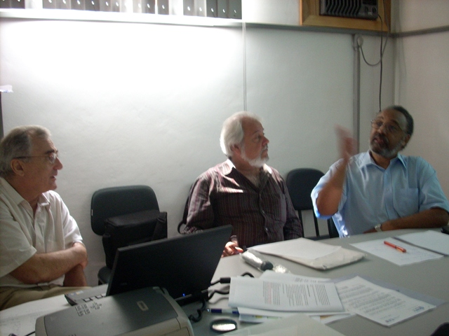
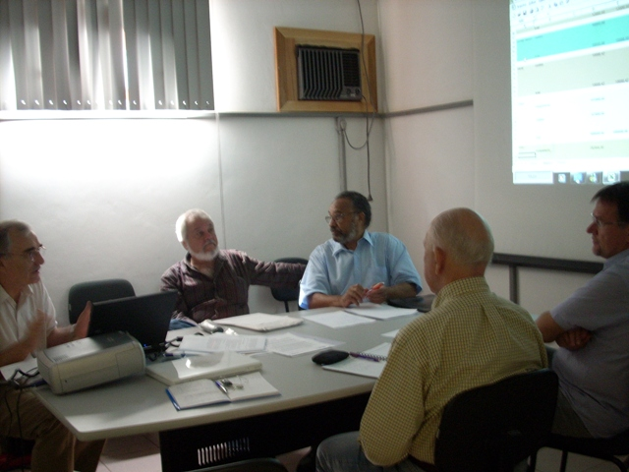

TEM Installation
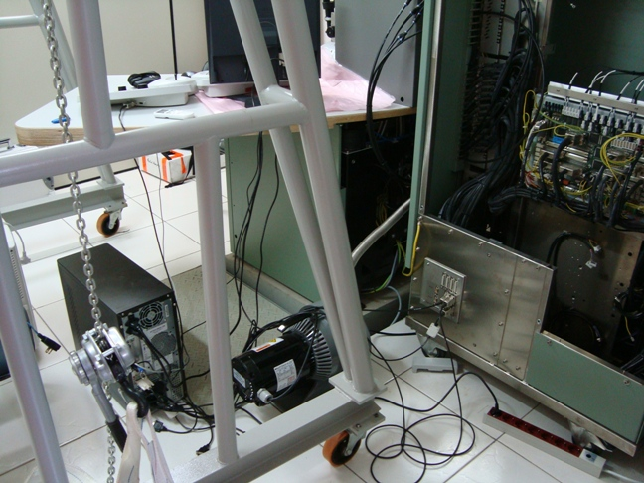
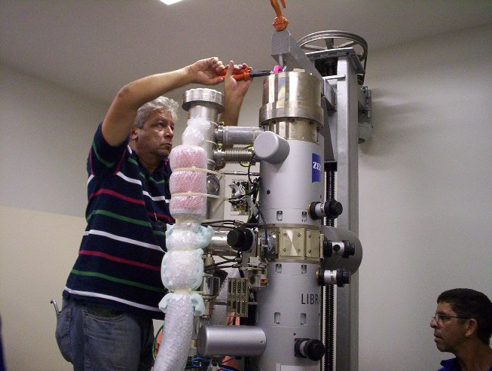
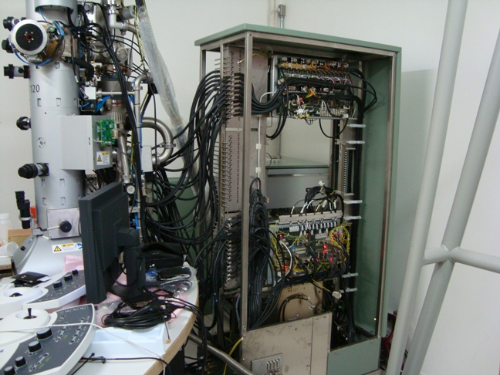
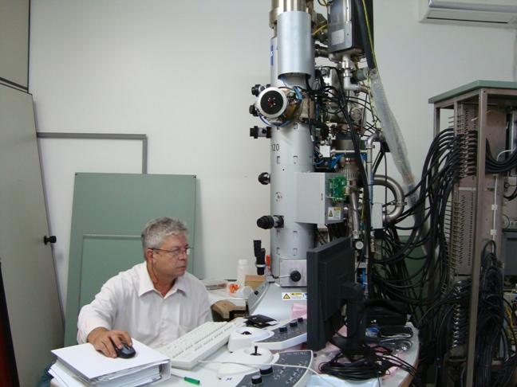

Conclusion

All the qualitative objectives of this project are being reached, at a high level. As for the quantitative targets, the projected numbers and current results are being largely exceeded, as shown in the following table.

 | Targets (5 years) | 2009 | 2010
Articles published in indexed periodicals | 300 | 95 | 12
Deposited patents | 20 | 4 | -
Presentations in international meetings | 100 | 54 | -
PhD theses approved | 40 | 13 | 3
Master theses approved | 60 | 12 | 3
Joint projects with industry | 15 | 13
Bulletins for dissemination of science and technology | 100 | 22 | 5
Speeches at education events | 50 | 21 | -
Speeches at events in companies and professional associations. | 50 | 30 | 3

Given the performance shown in the first period and since new equipment is now starting to became available, a significant qualitative and quantitative jump may be expected, for the next period of Inomat activities.

